1. Write Asp.Net Program to Demonstrate Use of HTML Controls.

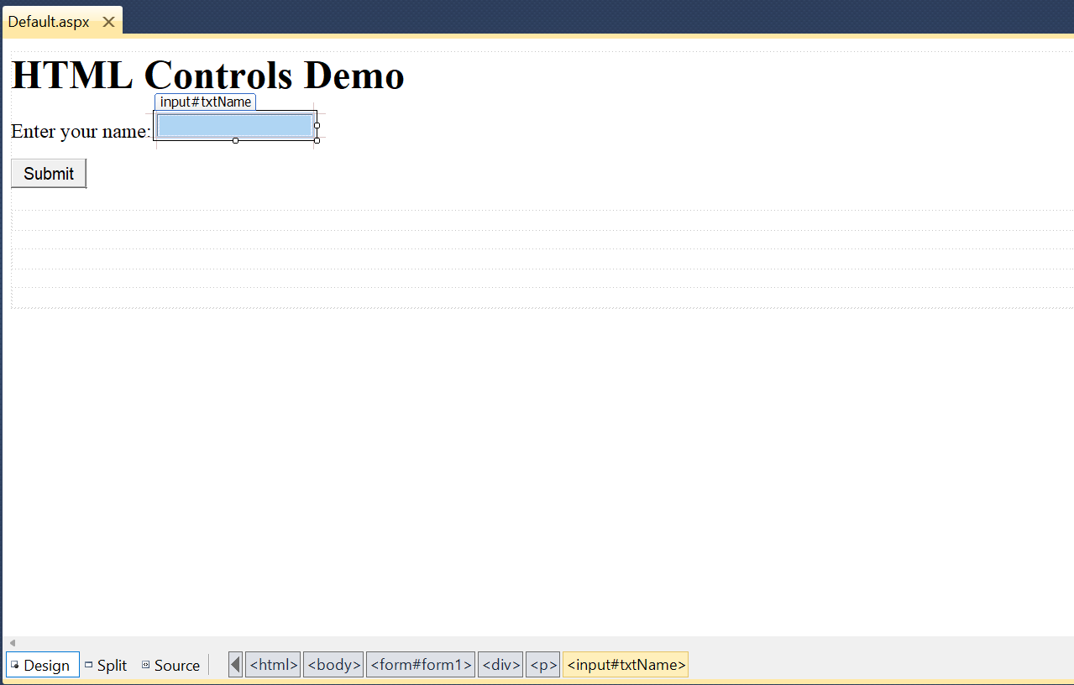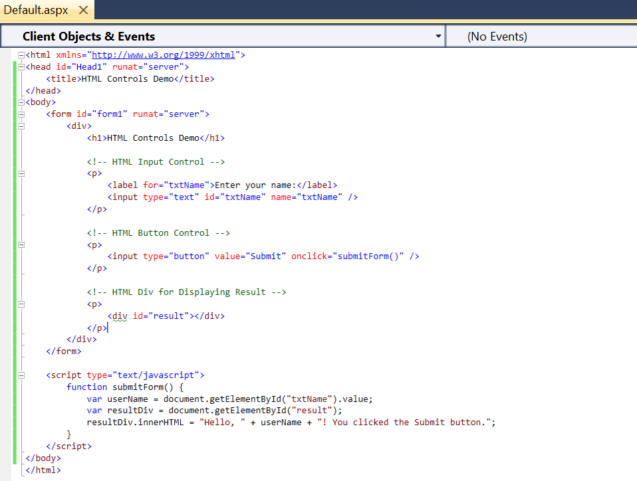

1. Write an ASP .net program that demonstrates use of web controls.

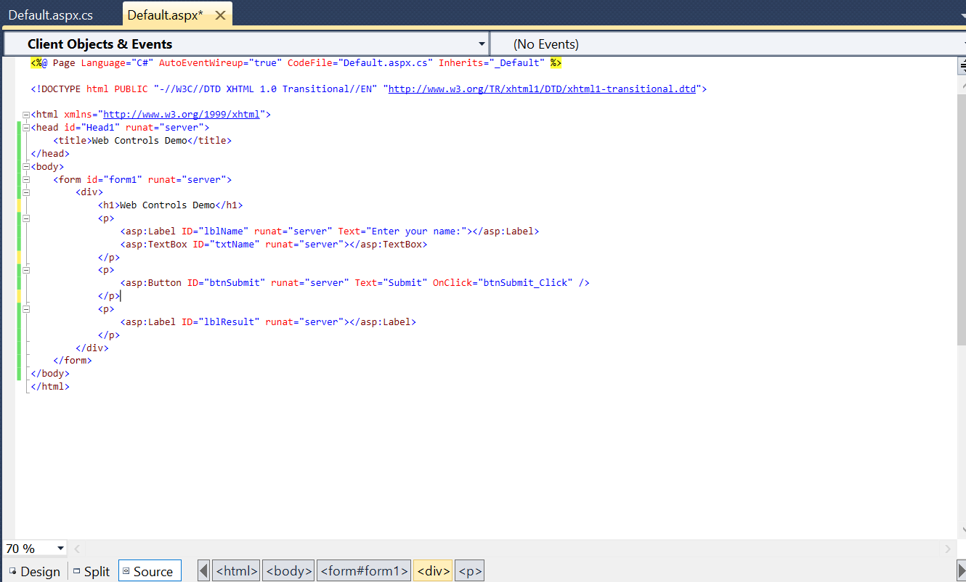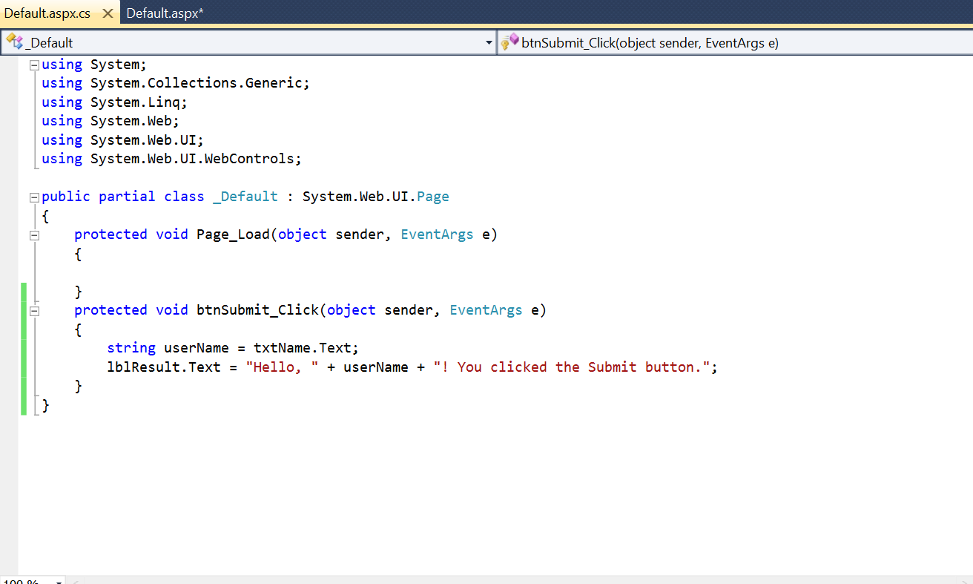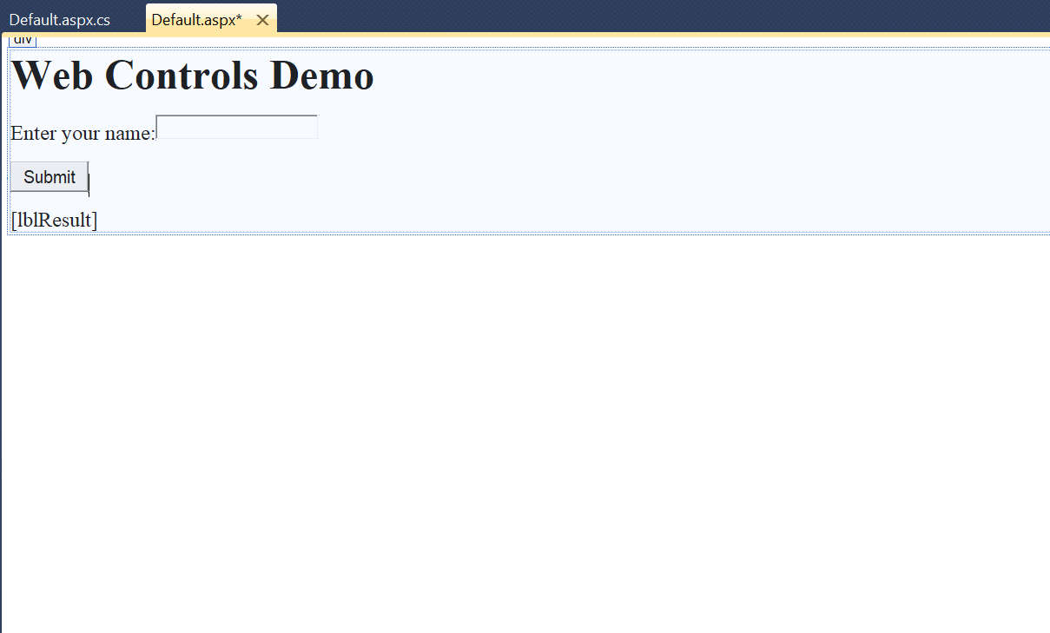

1. Write an ASP .net that returns the windows name of your computer and URL of the page that you are visiting.

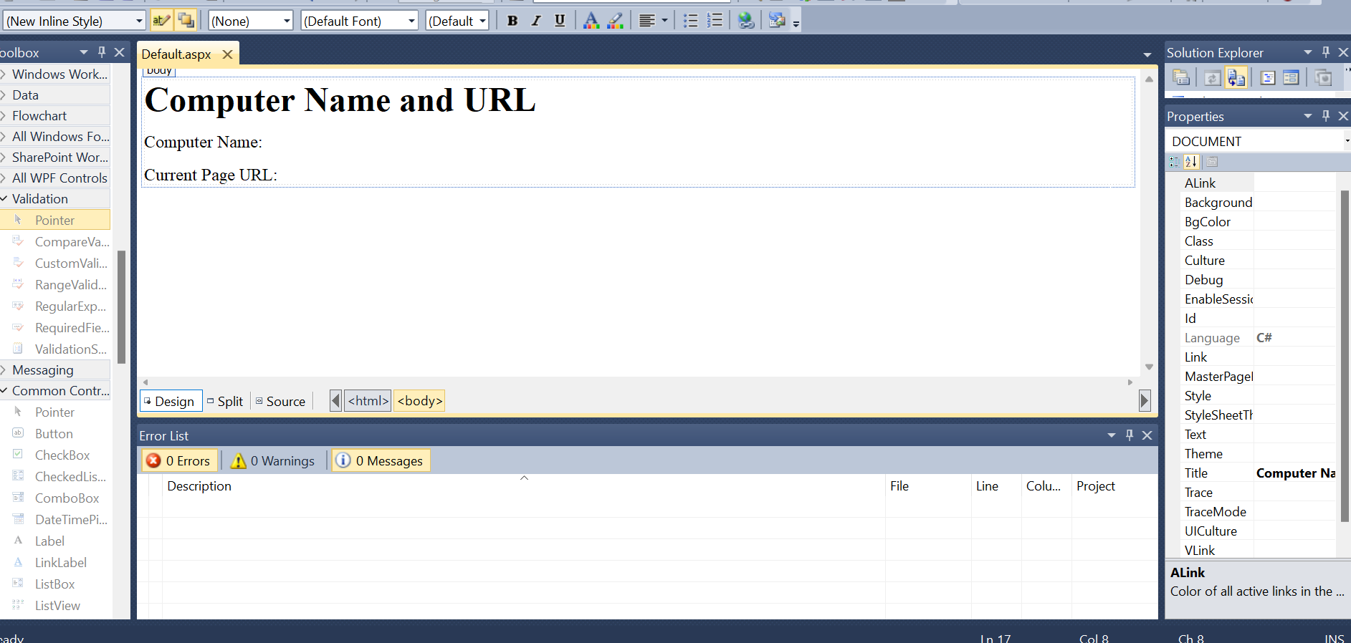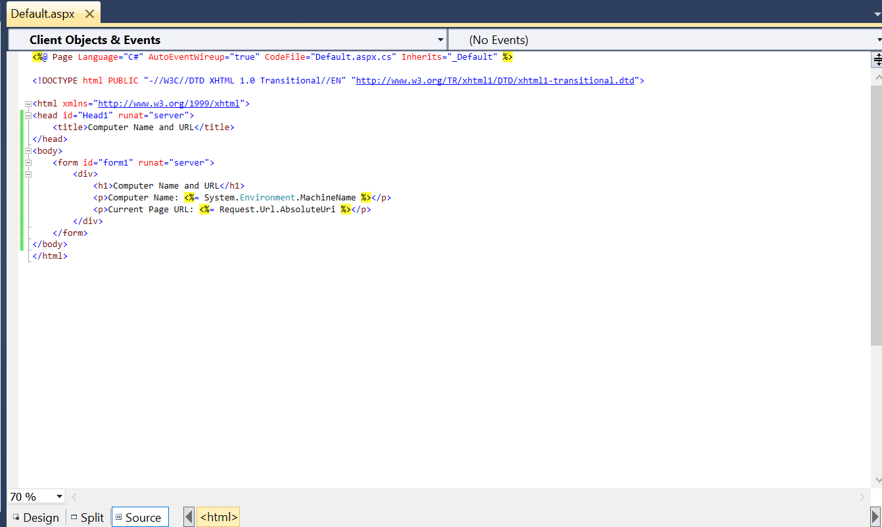

1. Write an ASP .net program that demonstrates use of Validations Controls.

Step 1:- Open Visual Studio 2010.

Step 2:-Create new webform (Student Information Form Show in SC).

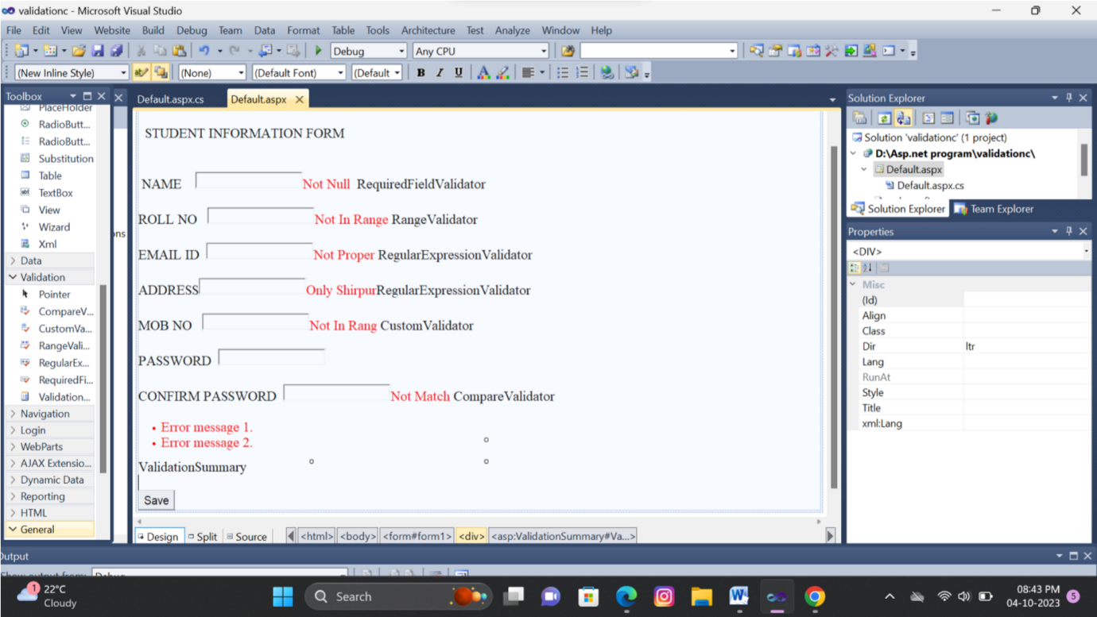

Step 3:-Go to View>ToolBox>Show the different Validation Controls.

Different types of Validation Controls:-

1. RequiredFieldValidator.
2. RangeValidator
3. CompareValidator
4. RegularExpressionValidator
5. CustomValidator
6. ValidationSummary

**1.RequiredFieldValidator :-**The RequiredFieldValidator control ensures that the required field is not empty. It is generally tied to a text box to force input into the text box.

**Properties:-**

**ControlToValidate:** Indicates the input control to validate.

**ErrorMessage:-** Indicates error string.

**Text:-** Error text to be shown if validation fails.

**ForeColor:-**It is error message text color.

Step 4:- Then Paste the RequiredFieldValidator in side of NAME text box .Click on validation control then set the properties of validation. (show in below sc)

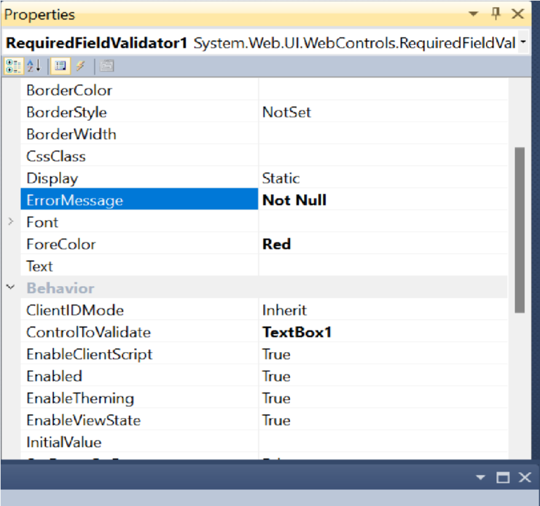

**2. RangeValidator:-** The RangeValidator control verifies that the input value falls within a predetermined range.

**Properties:-**

**ControlToValidate:** Indicates the input control to validate.

**ErrorMessage:-** Indicates error string.

It specifies the minimum value of

**MinimumValue:-** the range.

It specifies the maximum value of

**MaximumValue:-**

the range.

Step 5:- Then Paste theRangeValidator in side of EMAIL-ID text box .Click on validation control > set the properties of validation. (show in below sc)

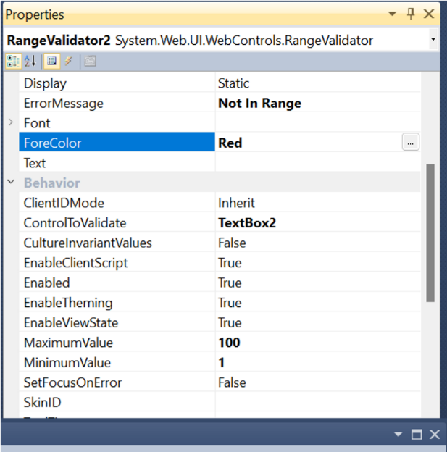

**3.RegularExpressionValidator:-** The

RegularExpressionValidator allows validating the input text by matching against a pattern of a regular expression. The regular expression is set in the ValidationExpression property.

**Properties:-**

**ControlToValidate:** Indicates the input control to validate.

**ErrorMessage:-** Indicates error string.

**ValidationExpression:-** It set different types the validation.

Step 5:- Then Paste theRegularExpressionValidator in side of ROLL NO text box .Click on validation control > set the properties of validation. (show in below sc)

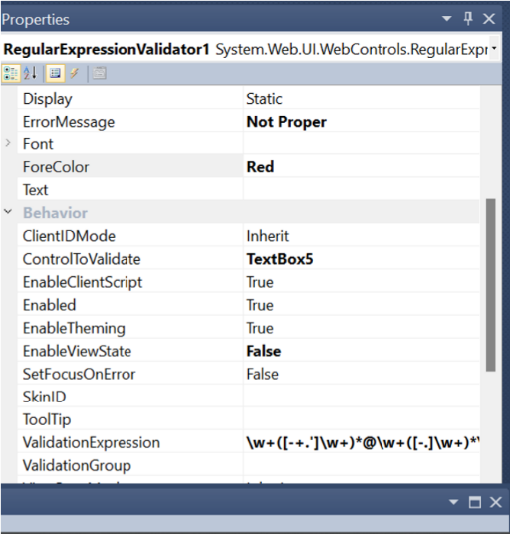

**4.CustomValidator:-** The CustomValidator control allows writing application specific custom validation routines for both the client side and the server side validation.

The client side validation is accomplished through the ClientValidationFunction property. The client side validation routine should be written in a scripting language, such as JavaScript or VBScript, which the browser can understand.

**Properties:-**

**ControlToValidate:** Indicates the input control to validate.

**ErrorMessage:-** Indicates error string.

**ClientValidationFuncation:-**To called the client side funcation.

Step 5:- Then Paste theCustom Validator in side of MOB NO text box .Click on validation control > set the properties of validation. Double click on control and write the code for client side validation and called the function on properties. (show in below sc)

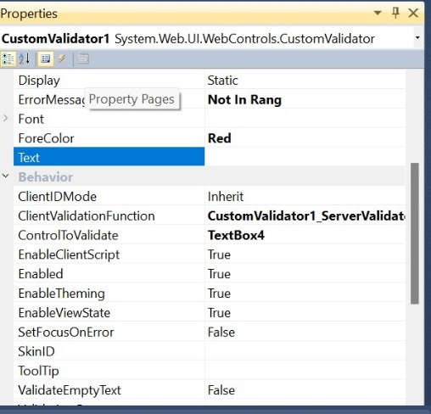

using System;

using System.Collections.Generic; using System.Linq; using System.Web; using System.Web.UI;

using System.Web.UI.WebControls;

public partial class _Default : System.Web.UI.Page

{

protected void Page_Load(object sender, EventArgs e)

{

}

protected void CustomValidator1_ServerValidate(object source,

ServerValidateEventArgs args)

{

}

protected void CustomValidator1_ServerValidate1(object source,

ServerValidateEventArgs args)

{

if (args.Value.Length >= 10) args.IsValid = true; else

args.IsValid = false;

}

}

**5.CompareValidator:-** The CompareValidator control compares a value in one control with a fixed value or a value in another control.

**Properties:-**

**ControlToValidate:** Indicates the input control to validate.

**ErrorMessage:-** Indicates error string.:

It specifies the value of the

**ControlToCompare:-** input control to compare with.

It specifies the constant value

**ValueToCompare:-** to compare with.

Step 6:- Then Paste theCompare Validator in side of CONFIRM PASSWORD text box .Click on validation control > set the properties of validation. (show in below sc)

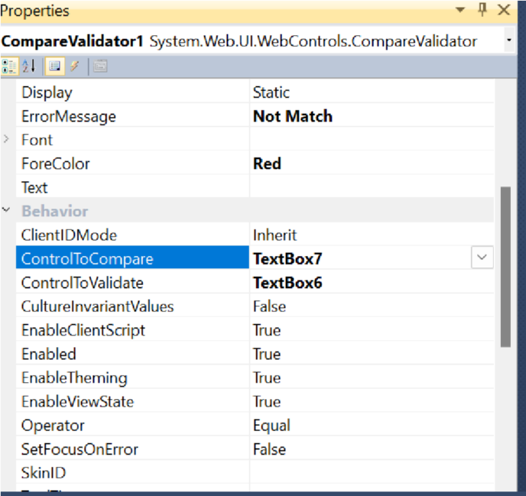

**6.ValidationSummary:-** Complex pages have different groups of information provided in different panels. To create a validation group, you should put the input controls and the validation controls into the same logical group by setting their *ValidationGroup* property.

**Properties:-**

* **ShowSummary** : shows the error messages in specified format.
* **ShowMessageBox** : shows the error messages in a separate window.

**OUTPUT:**

If type incorrect information the output is show error.(Validations)

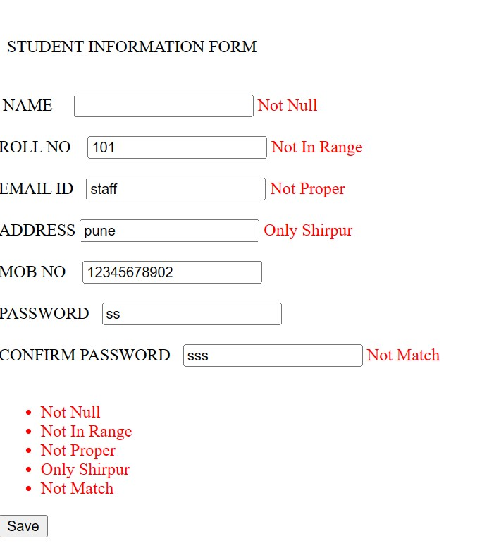

If type Correct Information output is:

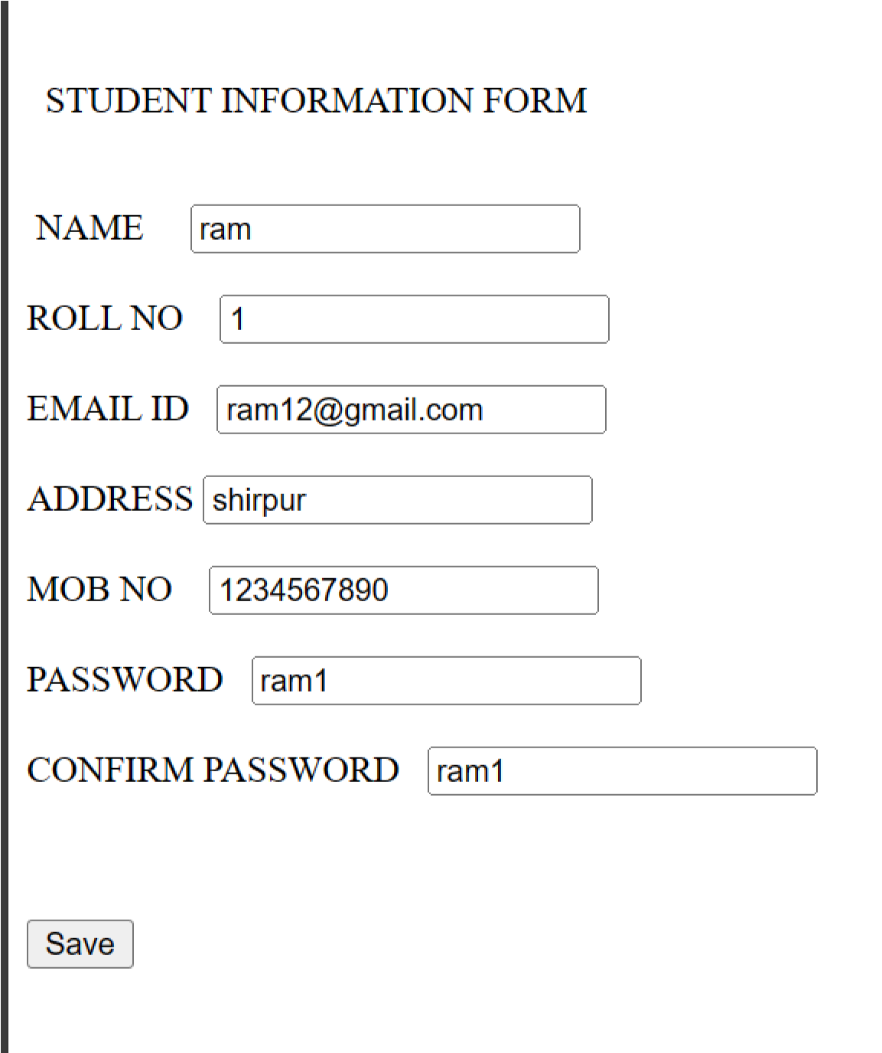

1. Write an ASP .net program that demonstrates use of Intrinsic Objects.

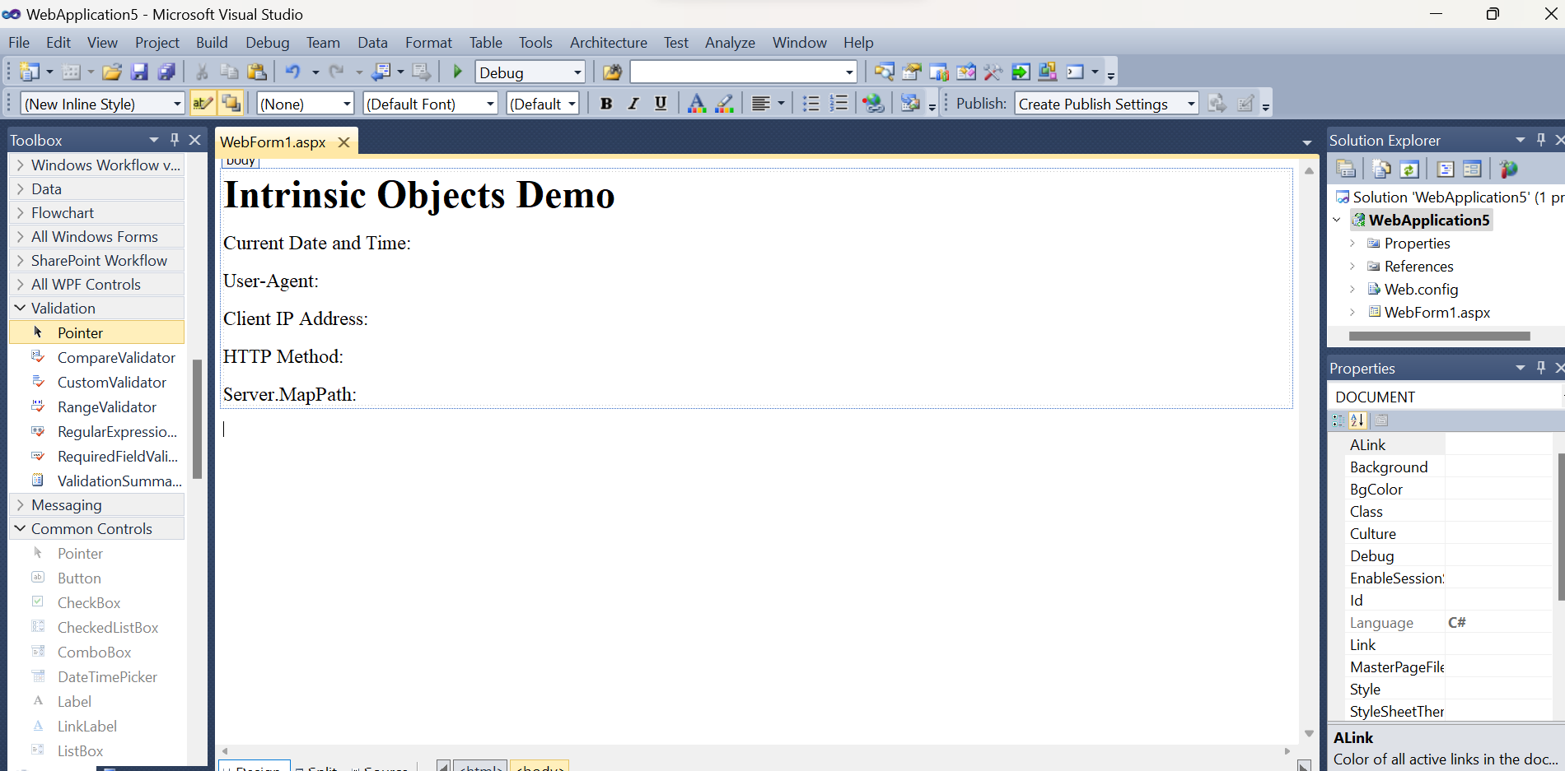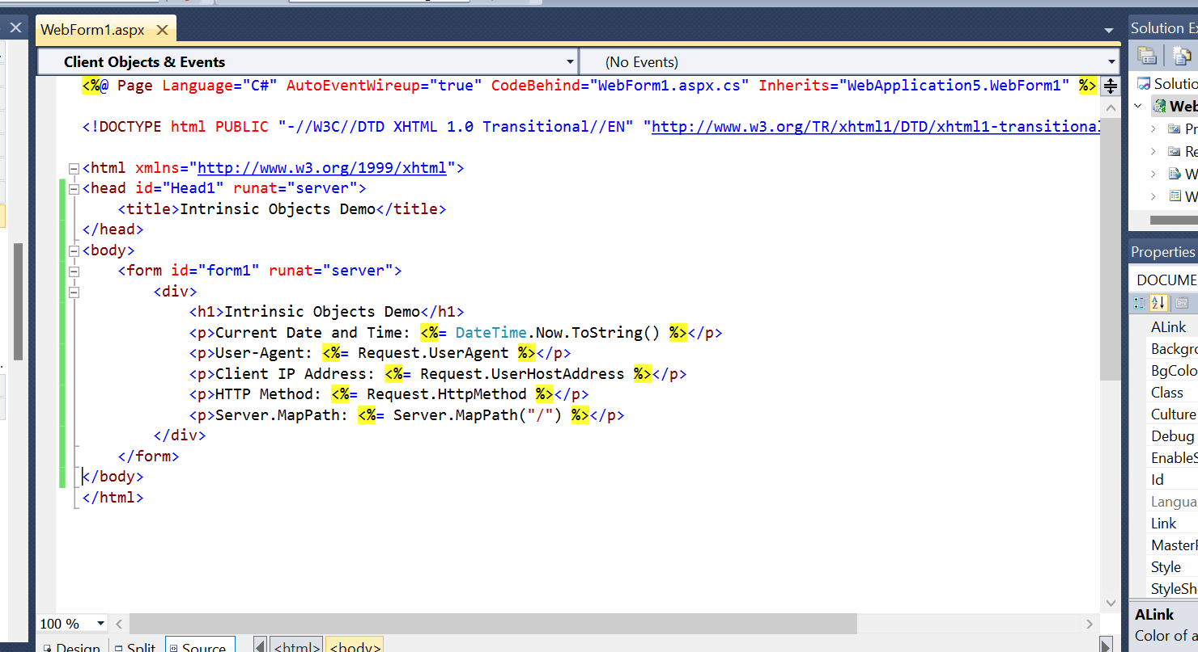

1. Write an ASP .net program that demonstrate Application and Session Scope Variables using

Global.Asax

Default.aspx

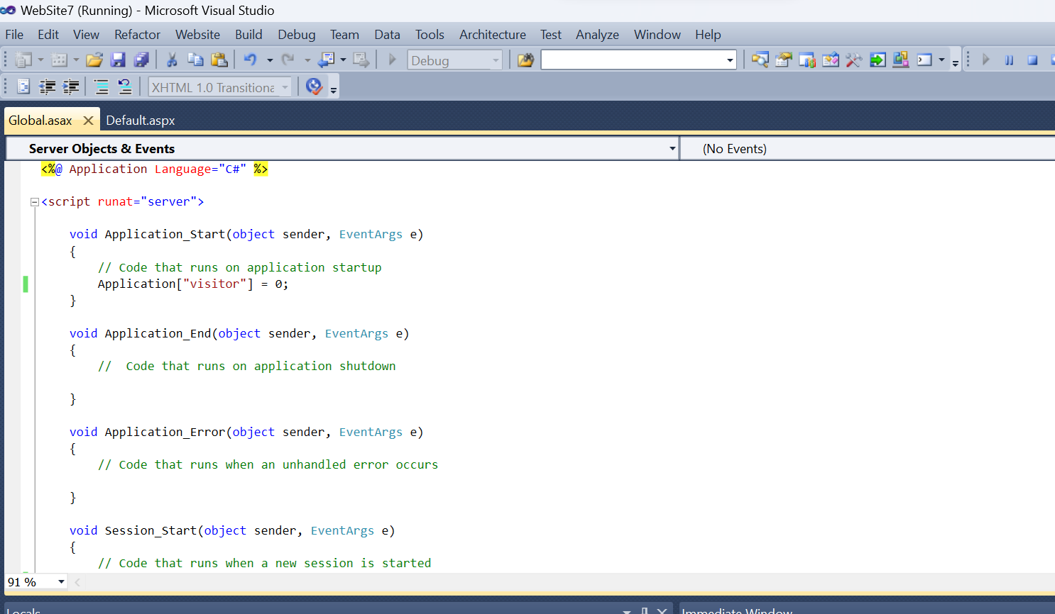

Global.asax





Output

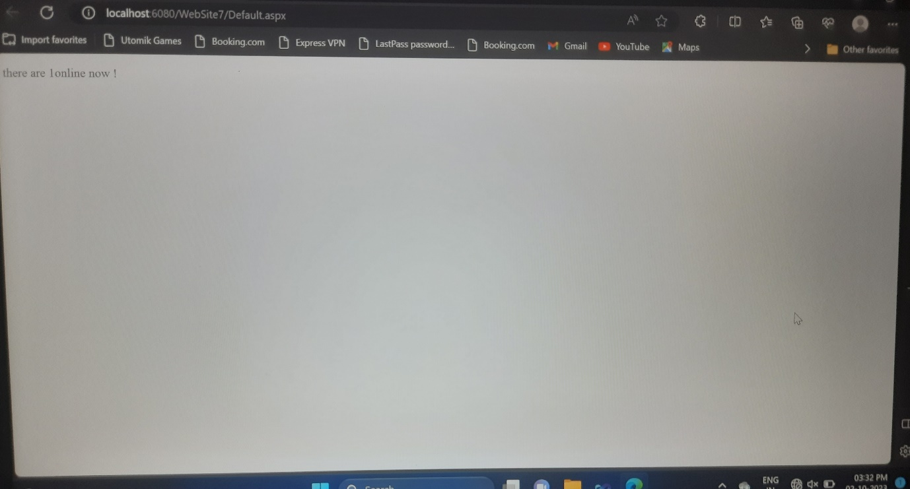

1. Write an ASP .net program Demonstrate use of Master Pages.
2. **Master page**

Step 1:- First You create ASP.NET empty website

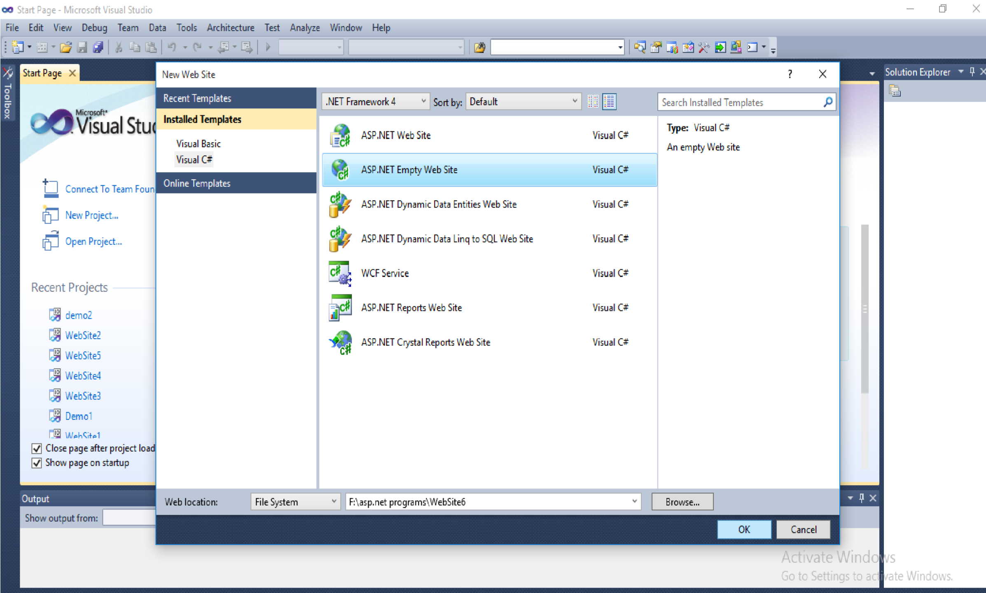

Step 2:- In Solution Explorer, right click on the name of your website and click on

‘add new item’.

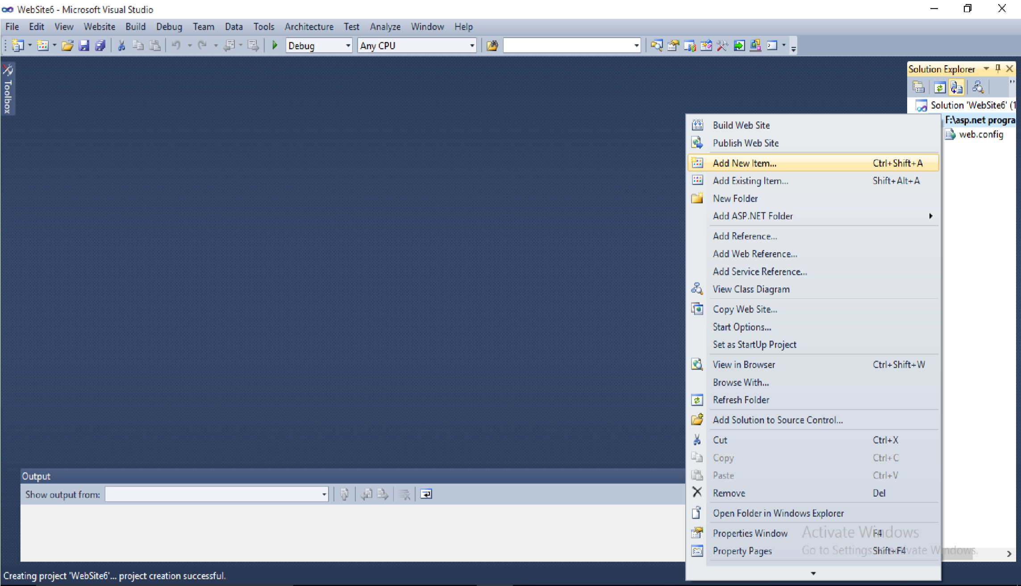

Step 3:- Under Visual Studio Template, click on master page and In name box type the name if you want to give it

Step 4:- Then Click on add button

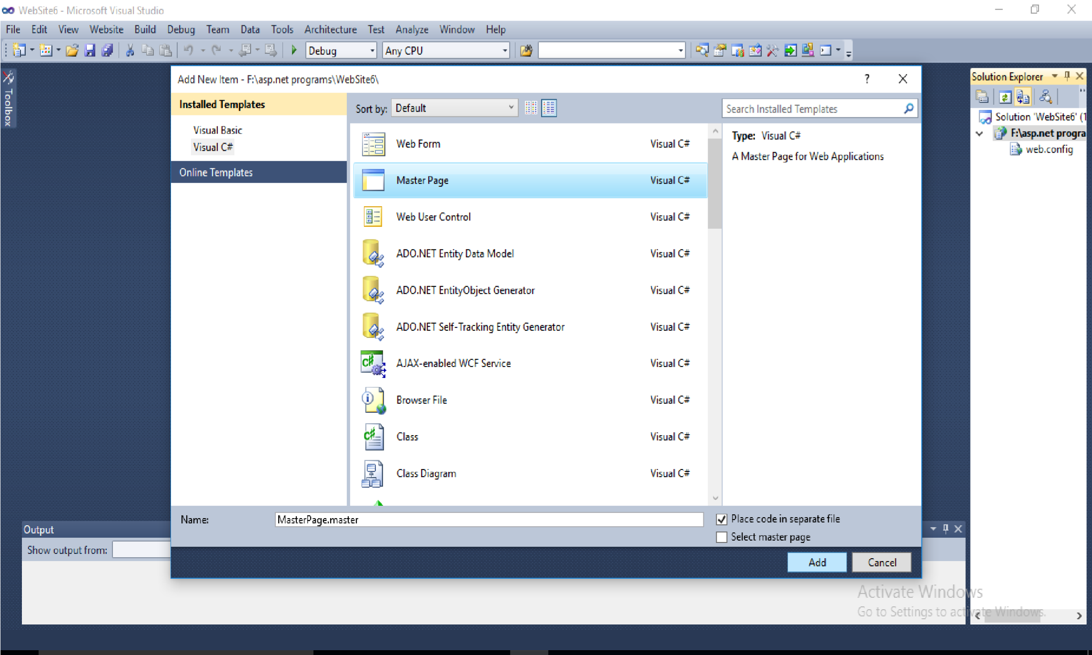

Step 5:- Then new master page opens in source view and Design it.

Step 6:- Add the ContentPlaceHolder control in content section of master page then

Save it.

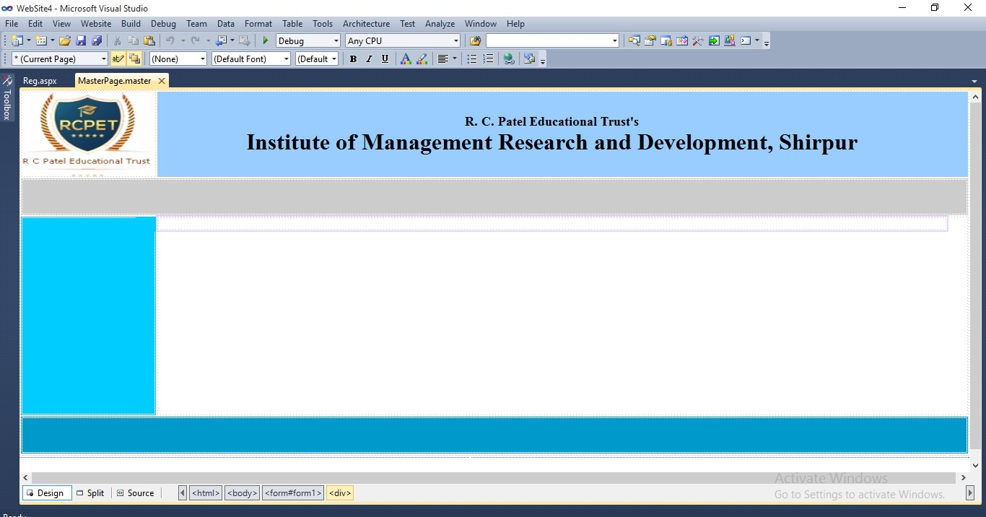

1. **Content Page**

Step 1:- In Solution Explorer, right click on the name of your website and click on ‘add new item’.

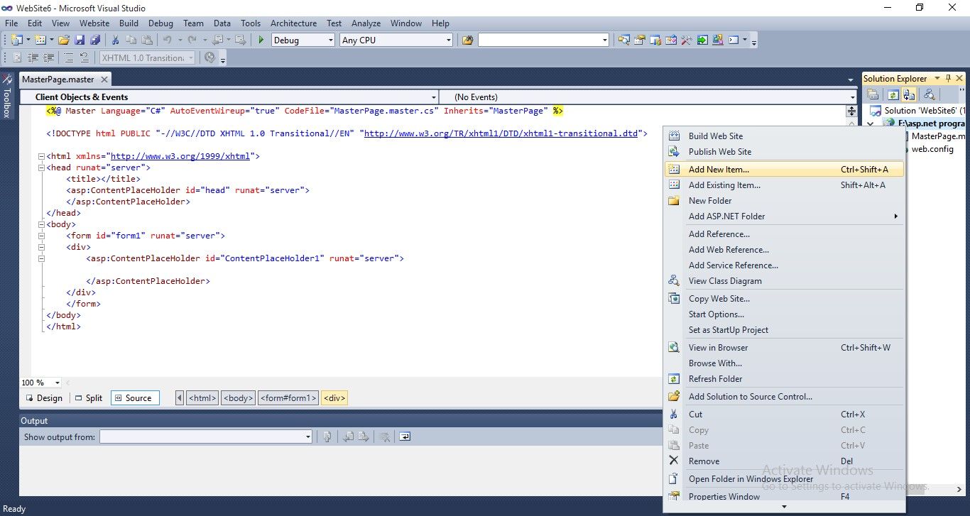

Step 2:- Under Visual Studio Template, click on Web form and In name box type the name if you want to give it.

Step 3:- Select the ‘Select master page’ check box and then click on add button.

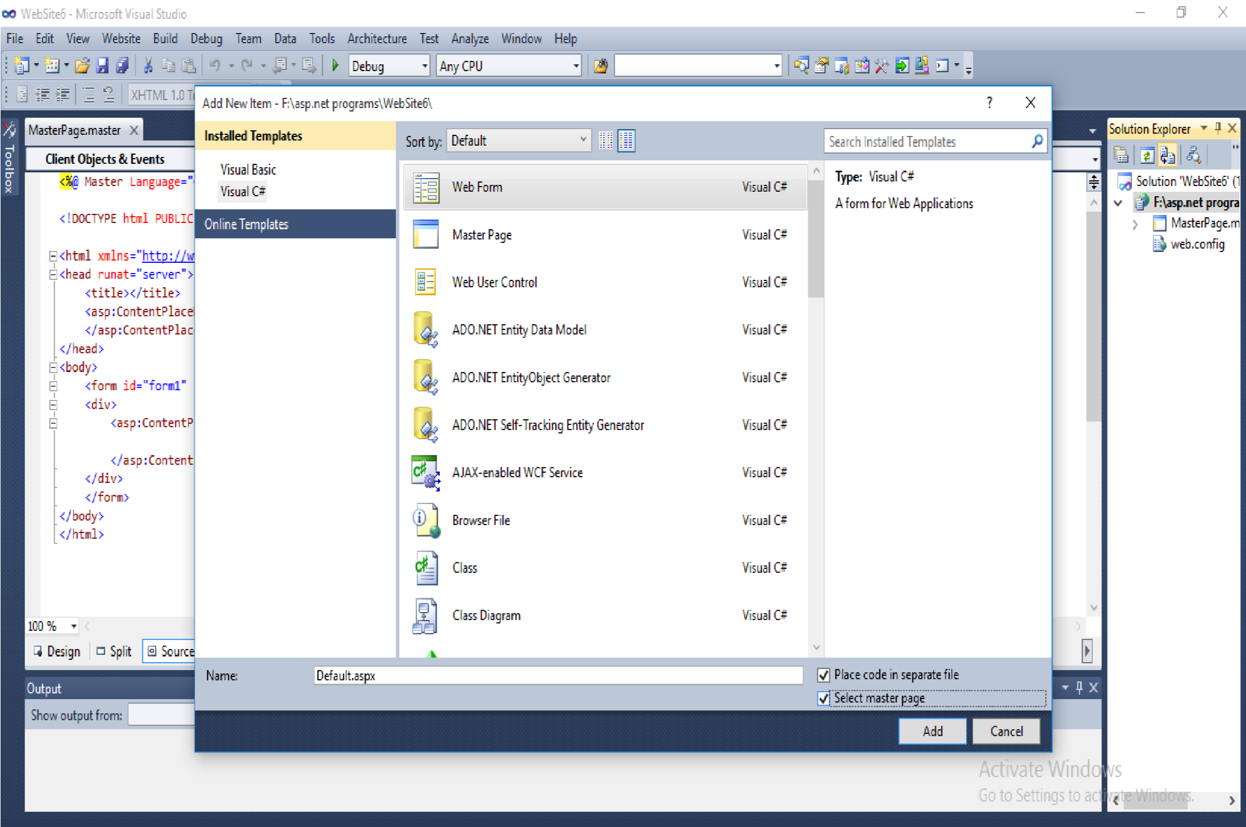

Step 4:- The select master page dialog box appears then click on .masert page and then click on ok buuton

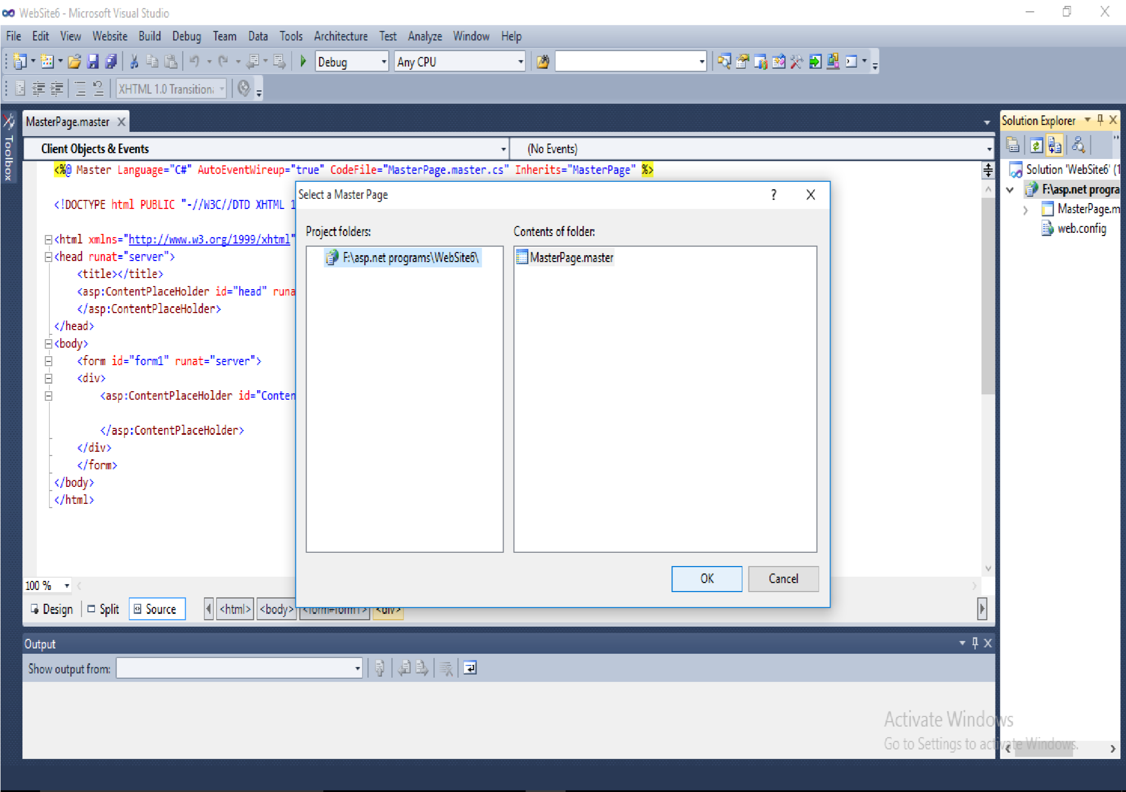

Step 5:- Then new .aspx file is created and you can add content in this file.

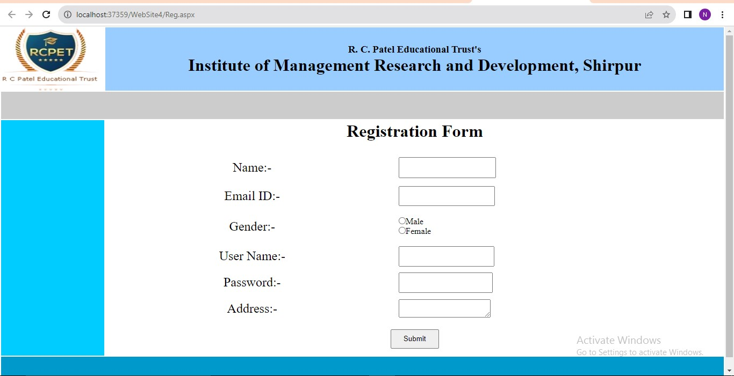

1. Write an ASP .net page that used the connection object to connect the database and display

information using Datagrid Controls.

**Default.aspx**

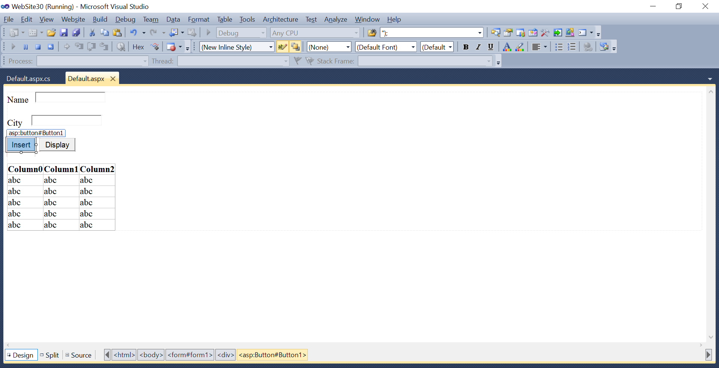

**Default.aspx.cs**

using System;

using System.Collections.Generic;

using System.Linq;

using System.Web;

using System.Web.UI;

using System.Web.UI.WebControls;

using System.Data.OleDb;

using System.Data;

public partial class _Default : System.Web.UI.Page

{

OleDbConnection con = new OleDbConnection("Provider=Microsoft.ACE.OLEDB.12.0;Data Source=C:\\Users\\HP\\Documents\\ritu\\Database3.accdb");

protected void Page_Load(object sender, EventArgs e)

{

}

protected void Button2_Click(object sender, EventArgs e)

{

DataTable dt = new DataTable();

con.Open();

OleDbDataAdapter da = new OleDbDataAdapter("select * from t1", con);

da.Fill(dt);

GridView1.DataSource = dt;

GridView1.DataBind();

con.Close();

}

}

1. Demonstrate website navigation controls using SiteMap file.
2. Demonstrate website navigation controls using Treeview file.
3. Demonstration of ASP.NET objects (HTTPApplicationState, HTTPSessionState)
4. Write an ASP .net program to demonstrates use of Asp.net Textbox,Checkbox,RadioButton and Button Control in Simple Web form.

**Default.aspx :-**

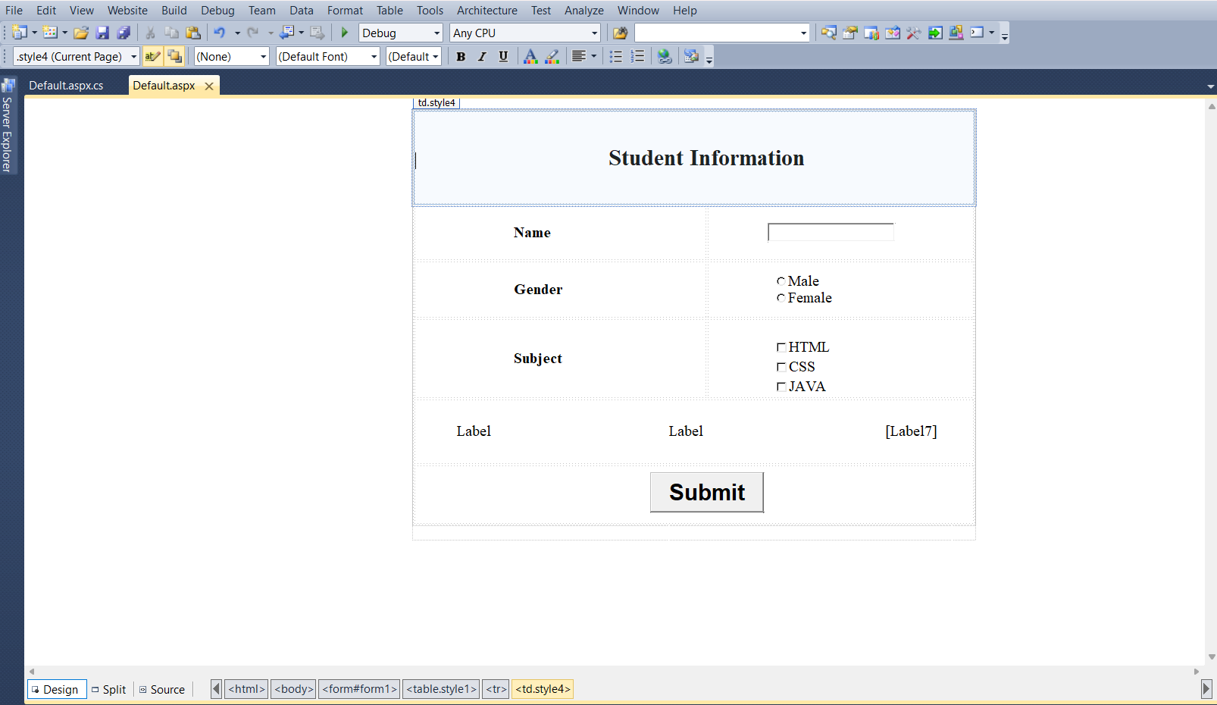

**Default.aspx.cs :-**

using System;

using System.Collections.Generic;

using System.Linq;

using System.Web;

using System.Web.UI;

using System.Web.UI.WebControls;

public partial class _Default : System.Web.UI.Page

{

protected void Page_Load(object sender, EventArgs e)

{

}

protected void Button1_Click(object sender, EventArgs e)

{

Label5.Text = TextBox1.Text;

if (RadioButton1.Checked == true)

{

Label6.Text = RadioButton1.Text;

}

else

{

Label6.Text = RadioButton2.Text;

}

foreach(ListItem Item in CheckBoxList1.Items)

{

if (Item.Selected)

{

Label7.Text += Item.Text + " ";

}

}

}

}

**Output :-**

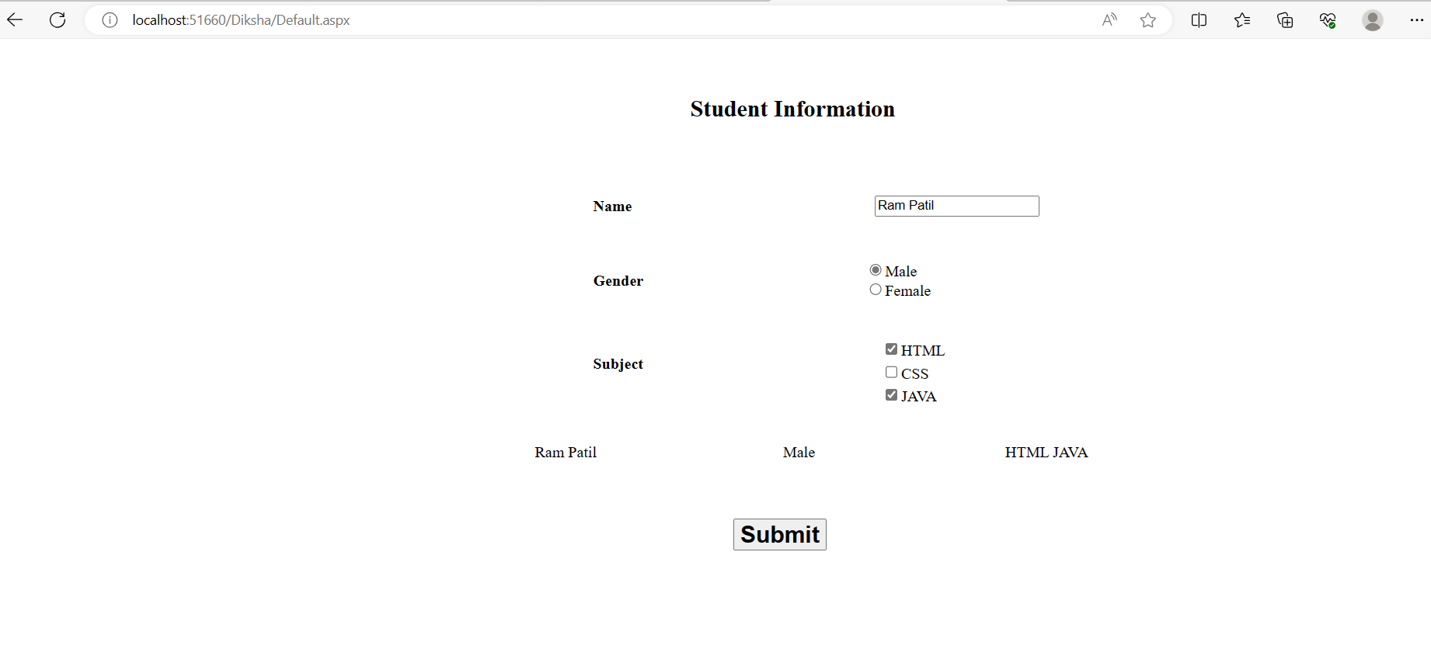

1. Write an ASP .net program to demonstrates use of Asp.net Dropdownlist , listbox and Button Control in Simple Web form.

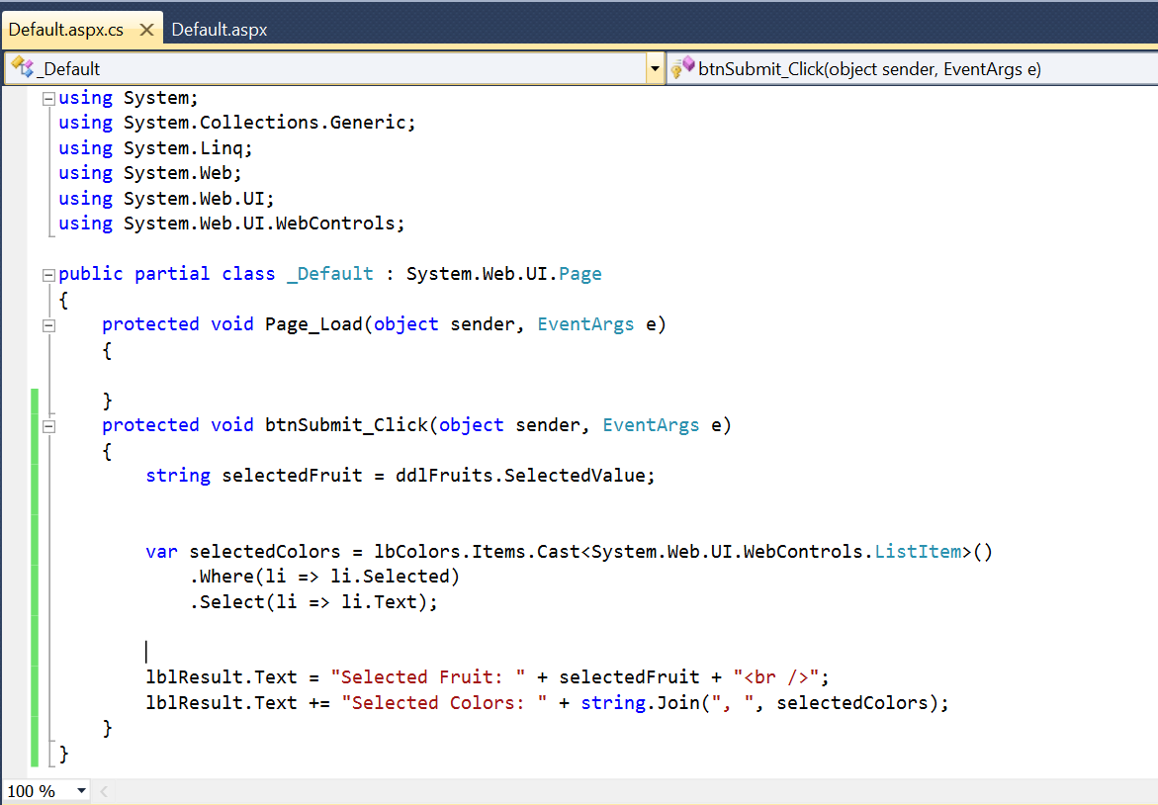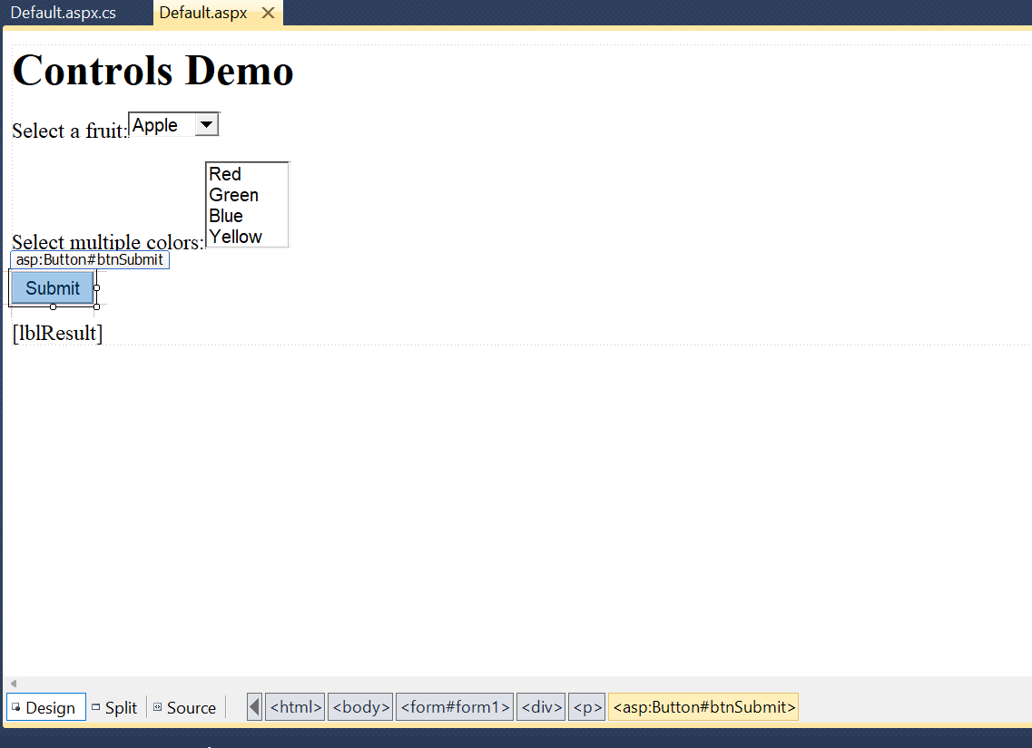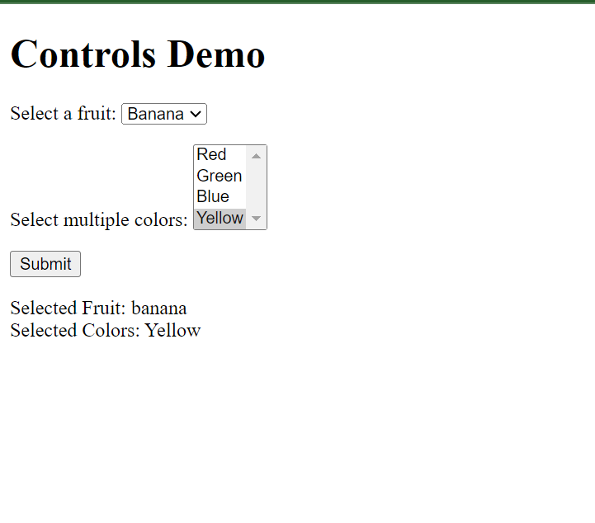

1. Write an ASP .net program to demonstrate how to detect Browser Capabilities.

**Default.aspx**

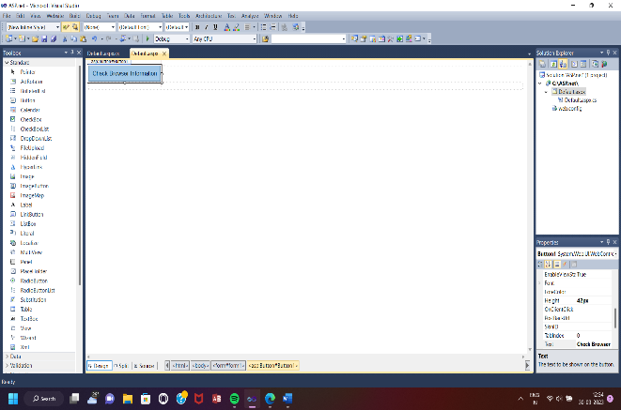

**Default.aspx.cs**

using System;

using System.Collections.Generic;

using System.Linq;

using System.Web;

using System.Web.UI;

using System.Web.UI.WebControls;

public partial class _Default : System.Web.UI.Page

{

protected void Page_Load(object sender, EventArgs e)

{

}

protected void Button1_Click(object sender, EventArgs e)

{

HttpBrowserCapabilities K;

K = Request.Browser;

Response.Write("<h1>Browser Information And Capabilities</h1>");

Response.Write("Browser Name is :-" + K.Browser + "<br>");

Response.Write("Browser Version is :-" + K.Version + "<br>");

Response.Write("Browser Support to tables:-" + K.Tables + "<br>");

Response.Write("Browser Support to JavaScript :-" + K.JavaScript + "<br>");

Response.Write("Browser Support to VBScript :-" + K.VBScript + "<br>");

Response.Write("Browser Support to Frames :-" + K.Frames + "<br>");

Response.Write("Browser Support to BackGround Sound :-" + K.BackgroundSounds+ "<br>");

Response.Write("Browser Support to Cookies :-" + K.Cookies + "<br>");

Response.Write("Browser ID is :-" + K.Id + "<br>");

Response.Write("Browser PlatForm is :-" + K.Platform+ "<br>");

}

**OutPut:**

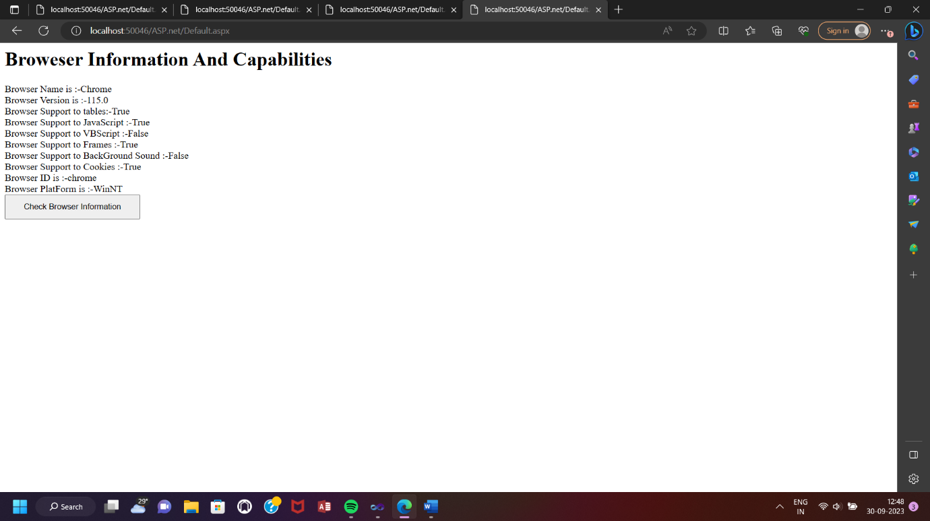

1. Write an ASP .net program to demonstrate how to handle application level errors.

**1)Default.aspx File:-**

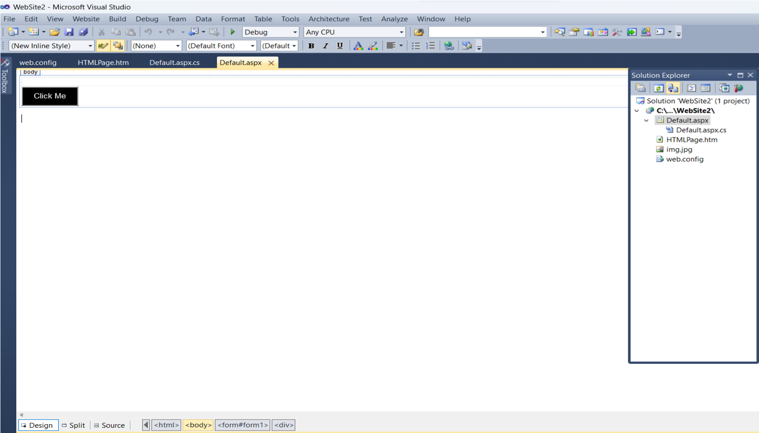

**3)**

**HTMLPage.htm**

**File**

**:**

**-**

**4)**

**Web.config**

**File:**

**-**

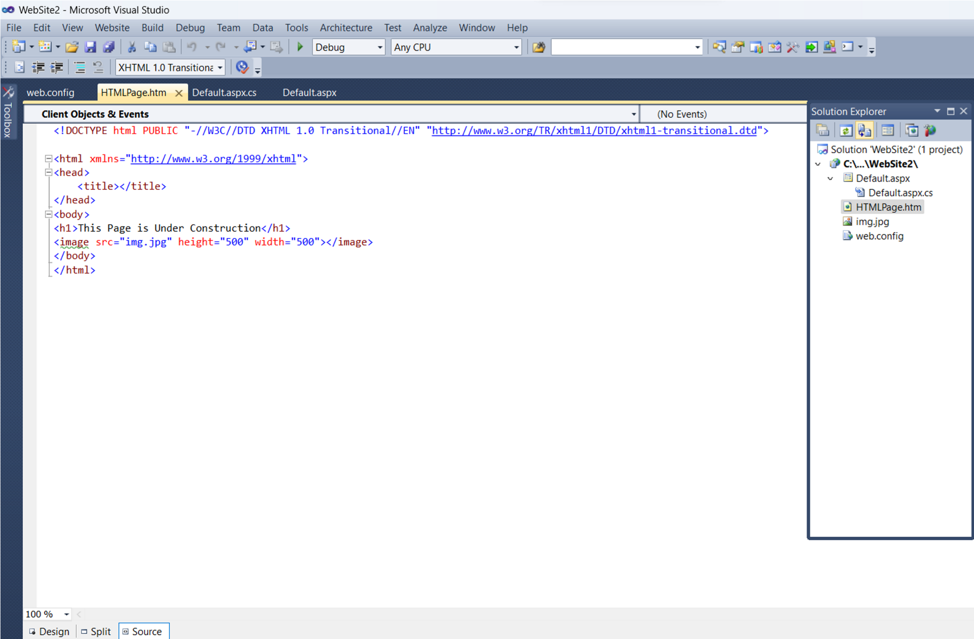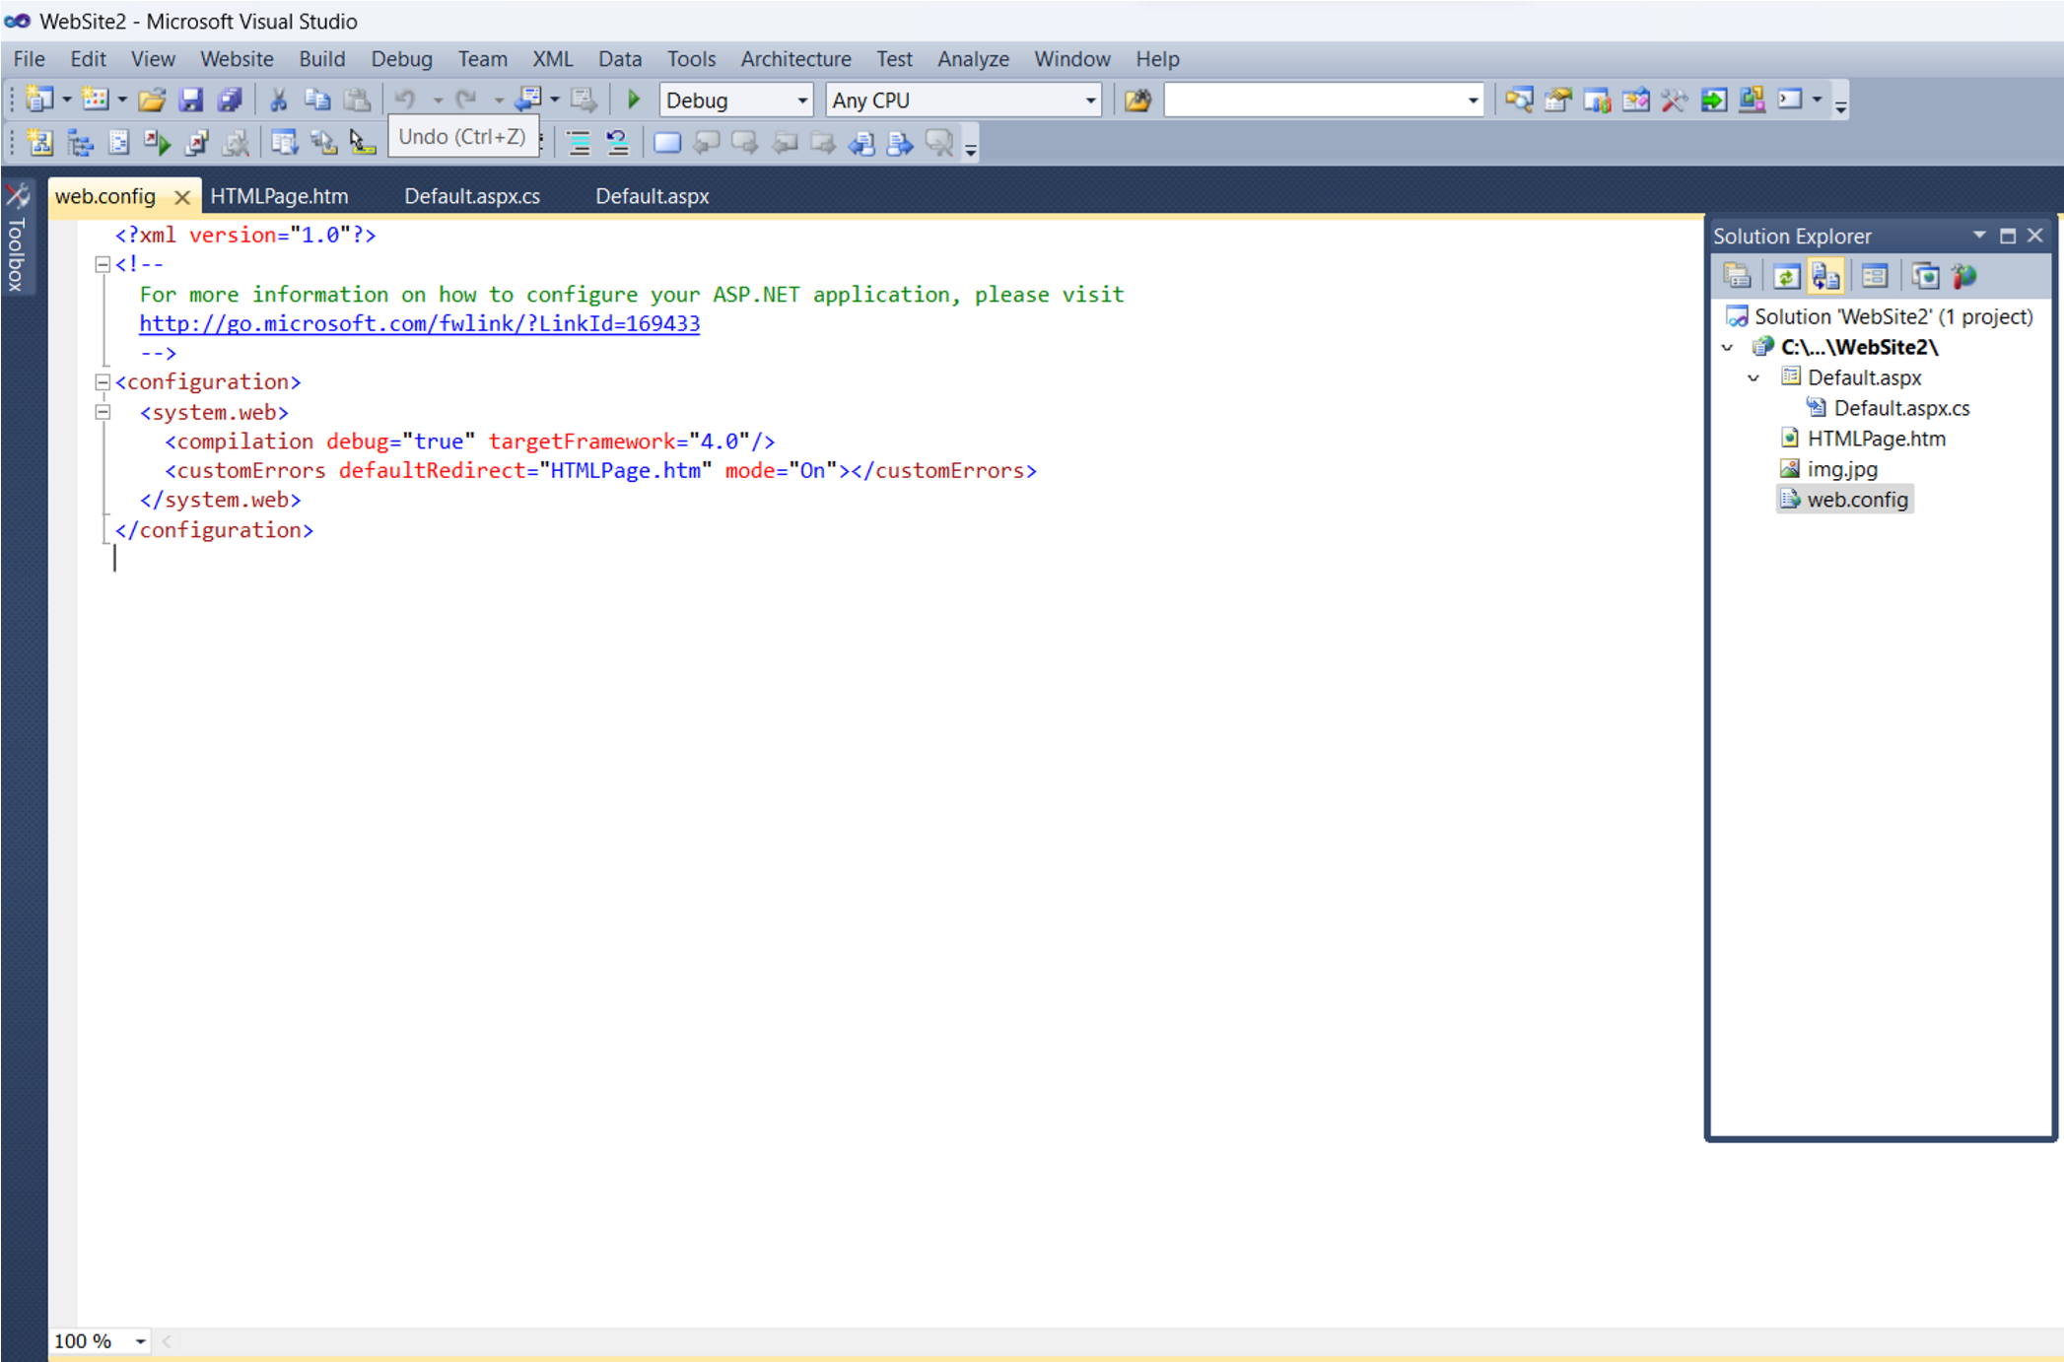

**Output**

**:**

**-**

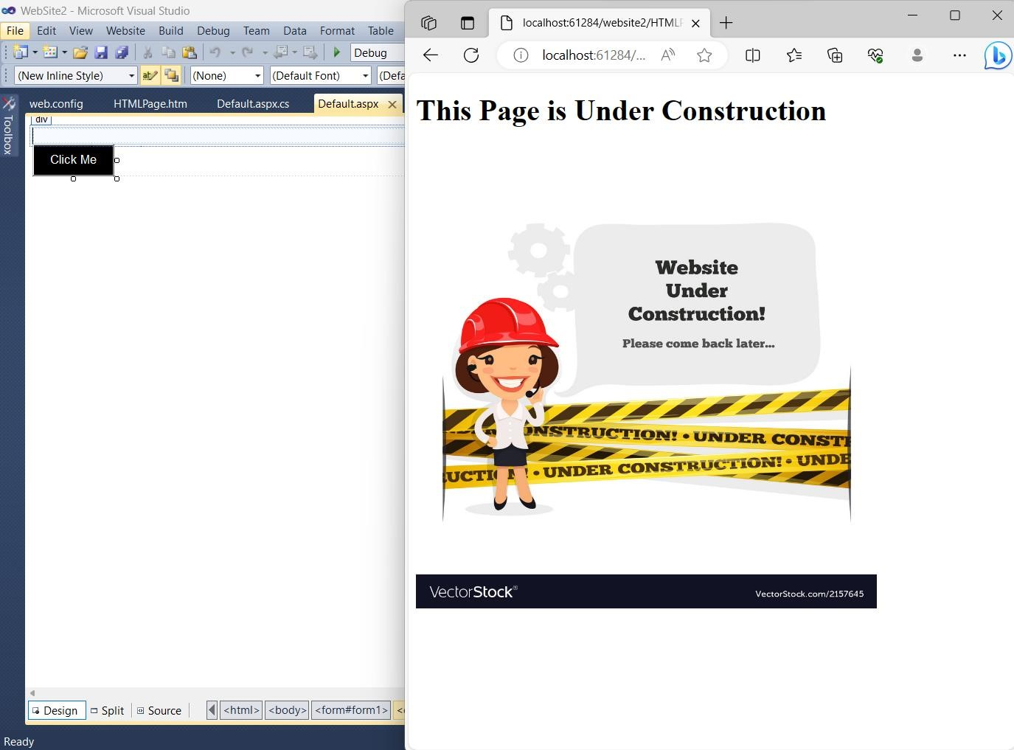

1. Write an ASP .net program to demonstrate use of server.Transfer() and Request.QueryString.

**1**

**)**

**Default.aspx file**

**:**

**-**

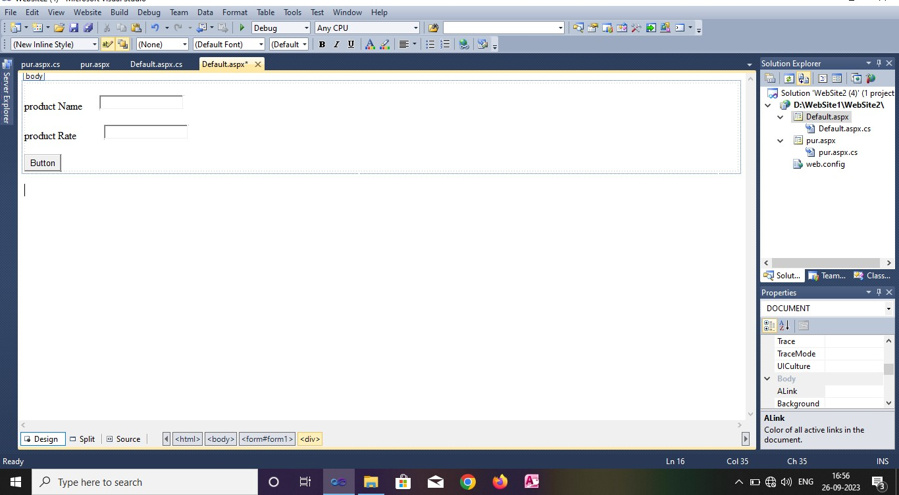

**3)pur.aspx file:-**

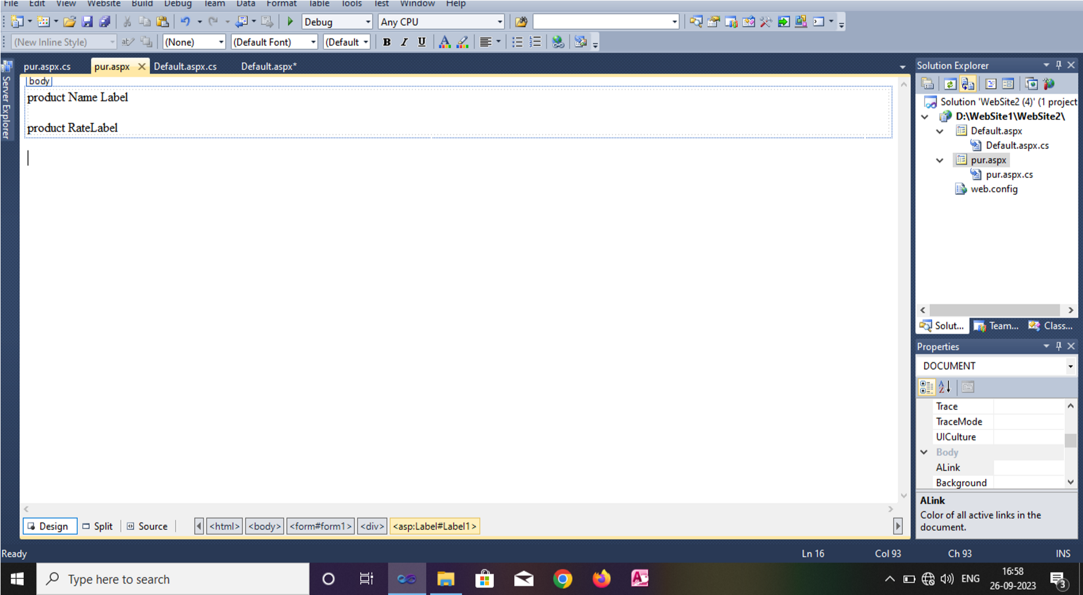

4**) pur.aspx.cs file**

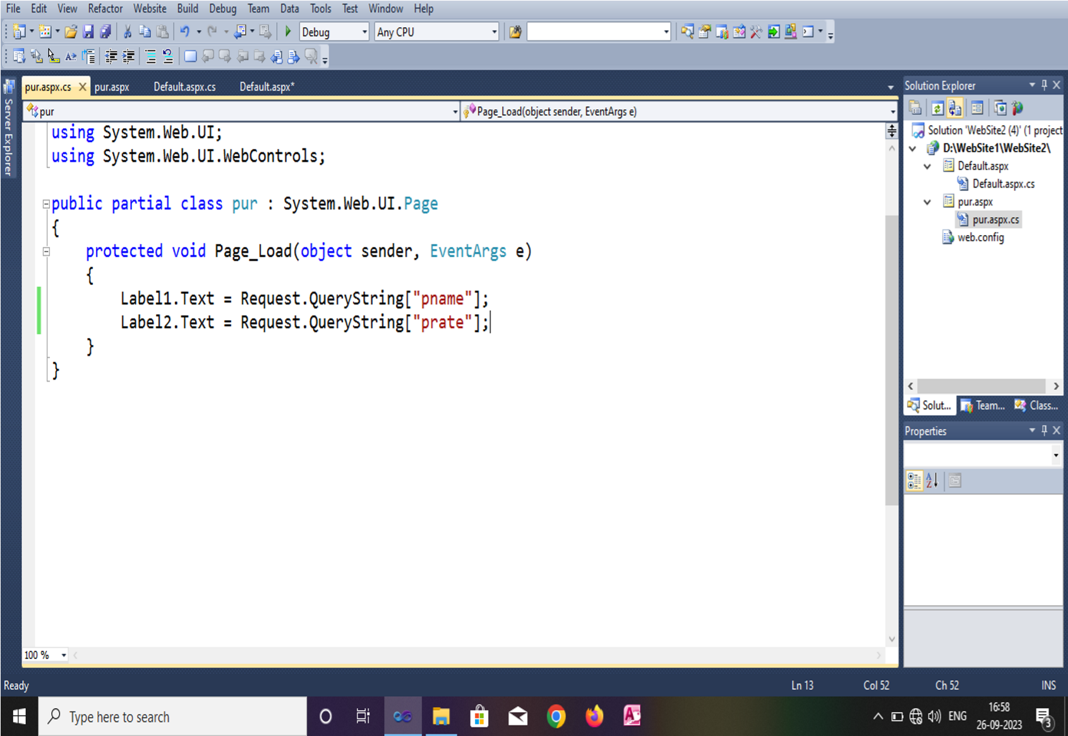

**Output:-**

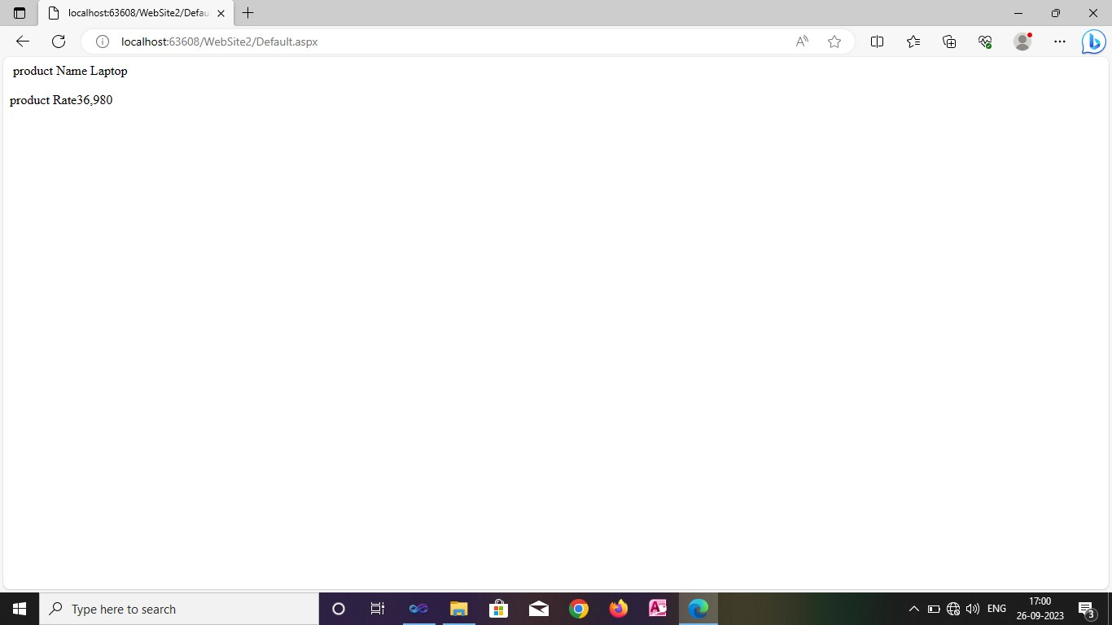

1. Write an ASP .net program to demonstrate insert, display operations with Microsoft Access Database.

**Default.aspx**



**Default.aspx.cs**

using System;

using System.Collections.Generic;

using System.Linq;

using System.Web;

using System.Web.UI;

using System.Web.UI.WebControls;

using System.Data.OleDb;

using System.Data;

public partial class _Default : System.Web.UI.Page

{

OleDbConnection con = new OleDbConnection("Provider=Microsoft.ACE.OLEDB.12.0;Data Source=C:\\Users\\HP\\Documents\\ritu\\Database3.accdb");

protected void Page_Load(object sender, EventArgs e)

{

}

//Insert Data

protected void Button1_Click(object sender, EventArgs e)

{

con.Open();

OleDbCommand cmd = new OleDbCommand("insert into t1 values('" + TextBox1.Text + "','" + TextBox2.Text + "')", con);

cmd.ExecuteNonQuery();

con.Close();

Response.Write("<script LANGUAGE='JavaScript'>alert('Data insert sucessfully...!')</script>");

}

//Display

protected void Button2_Click(object sender, EventArgs e)

{

DataTable dt = new DataTable();

con.Open();

OleDbDataAdapter da = new OleDbDataAdapter("select * from t1", con);

da.Fill(dt);

GridView1.DataSource = dt;

GridView1.DataBind();

con.Close();

}

}

**Output :**

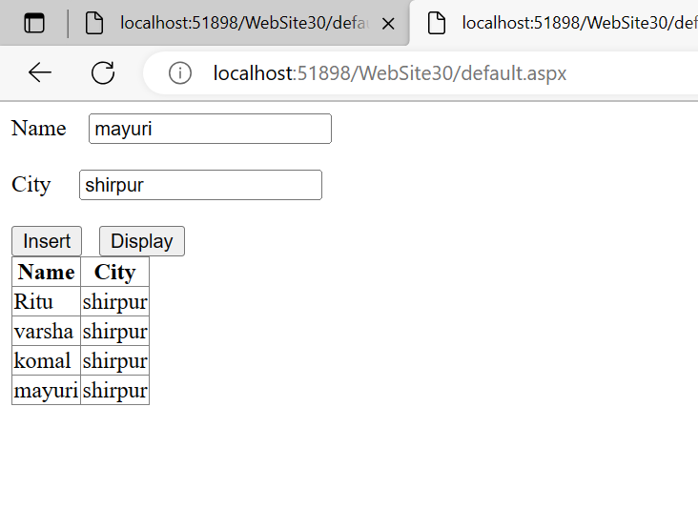

1. Write an ASP .net program to demonstrate insert, delete and display operations with Microsoft Access Database.

**Reg.aspx**

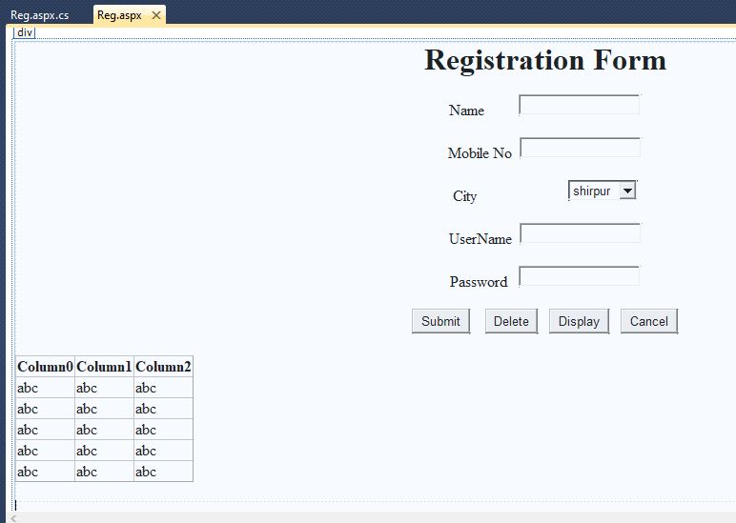

**Reg.aspx.cs**

using System;

using System.Collections.Generic;

using System.Linq;

using System.Web;

using System.Web.UI;

using System.Web.UI.WebControls;

using System.Data.OleDb;

using System.Data;

public partial class _Default : System.Web.UI.Page

{

OleDbConnection con = new OleDbConnection("Provider=Microsoft.ACE.OLEDB.12.0;Data Source=C:\\Users\\COM\\OneDrive\\Documents\\stud.accdb");

protected void Page_Load(object sender, EventArgs e)

{

}

**//Insert Data**

protected void Button1_Click(object sender, EventArgs e)

{

con.Open();

OleDbCommand cmd = new OleDbCommand("insert into stud values('" + TextBox1.Text + "','" + TextBox2.Text + "','"

+ DropDownList1.SelectedItem.ToString() + "','" + TextBox3.Text + "','" + TextBox4.Text + "')", con);

cmd.ExecuteNonQuery();

con.Close();

Response.Write("<script LANGUAGE='JavaScript' >alert('Data insert Successfully..!')</script>");

}

**//Delete Data**

protected void Button2_Click(object sender, EventArgs e)

{

OleDbCommand cmd = new OleDbCommand("delete from stud where password ='"+TextBox4.Text+"'",con);

con.Open();

cmd.ExecuteNonQuery();

Response.Write("<script LANGUAGE='JavaScript' >alert('Data Delete Successfully..!')</script>");

con.Close();

}

**//View Data**

protected void Button3_Click(object sender, EventArgs e)

{

DataTable dt = new DataTable();

con.Open();

OleDbDataAdapter da = new OleDbDataAdapter("select * from stud",con);

da.Fill(dt);

GridView1.DataSource = dt;

GridView1.DataBind();

con.Close();

}

protected void GridView1_SelectedIndexChanged(object sender, EventArgs e)

{

TextBox1.Text = GridView1.SelectedRow.Cells[1].Text;

TextBox2.Text = GridView1.SelectedRow.Cells[2].Text;

DropDownList1.SelectedItem.Text = GridView1.SelectedRow.Cells[3].Text.ToString();

TextBox3.Text = GridView1.SelectedRow.Cells[4].Text;

TextBox4.Text = GridView1.SelectedRow.Cells[5].Text;

}

**//Clear fields**

protected void Button4_Click(object sender, EventArgs e)

{

TextBox1.Text = "";

TextBox2.Text = "";

TextBox3.Text = "";

TextBox4.Text = "";

}

}

**Output**

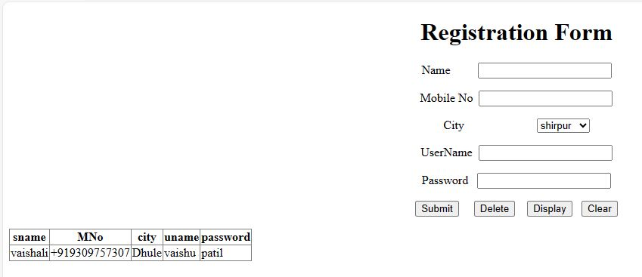

1. Write an ASP .net program to demonstrate how we can create and retrieve cookies.

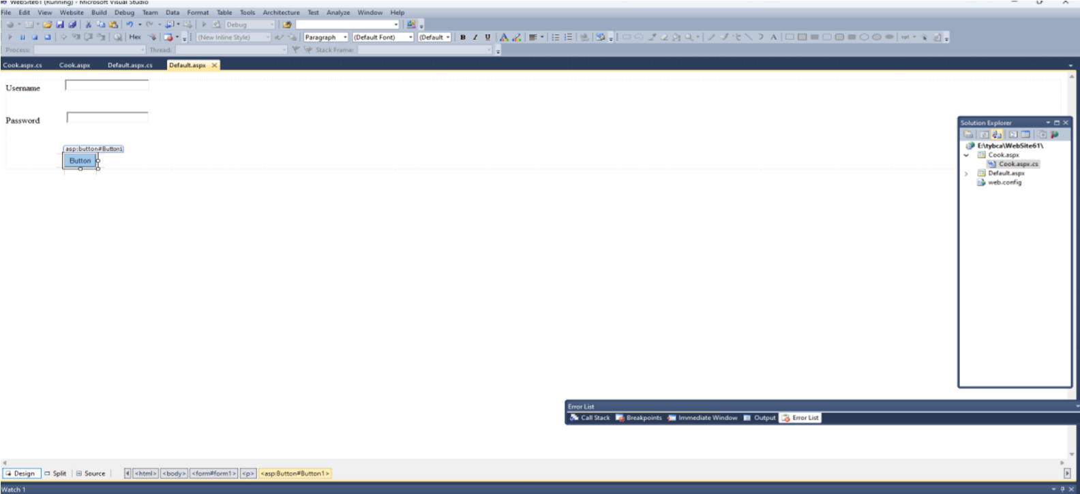

Default.aspx.cs

usingSystem; usingSystem.Collections.Generic; usingSystem.Linq; usingSystem.Web; usingSystem.Web.UI; usingSystem.Web.UI.WebControls;

publicpartialclass_Default:System.Web.UI.Page

{

protectedvoidPage_Load(objectsender,EventArgse)

{

}

protectedvoidButton1_Click(objectsender,EventArgse)

{

Response.Cookies["rcp"].Value=TextBox1.Text;

Response.Cookies["rcp"].Expires.AddDays(1);

Response.Redirect("Cook.aspx");

}

}

Cook.aspx

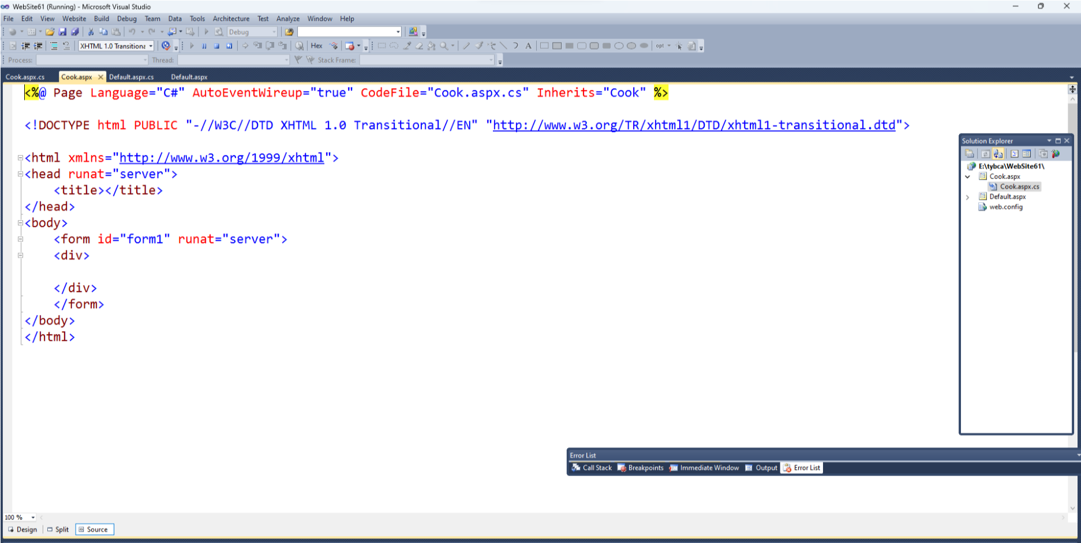

Cook.aspx.cs

usingSystem;

usingSystem.Collections.Generic; usingSystem.Linq; usingSystem.Web; usingSystem.Web.UI; usingSystem.Web.UI.WebControls;

publicpartialclassCook:System.Web.UI.Page

{

protectedvoidPage_Load(objectsender,EventArgse)

{

Response.Write("WelCome"+""+Request.Cookies["rcp"].Value.ToString()+"OnmyWebsite");

}

}

Output:

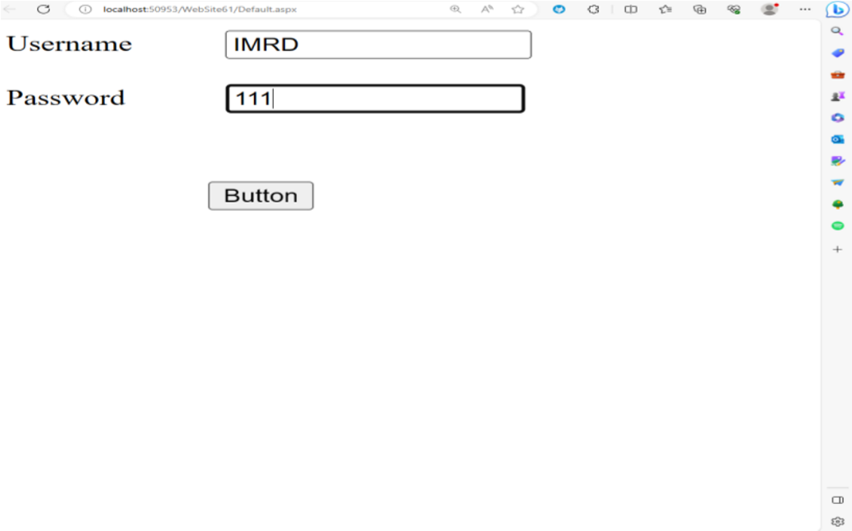

OUTPUT:

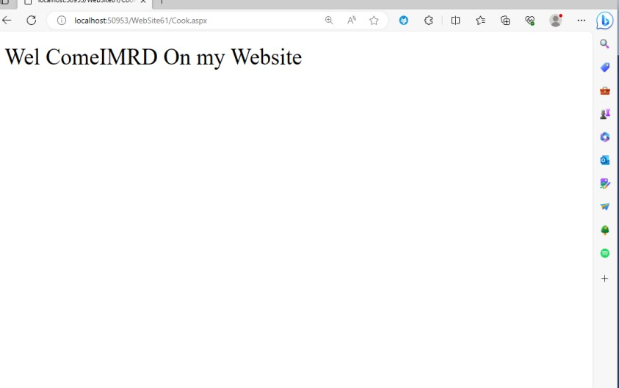

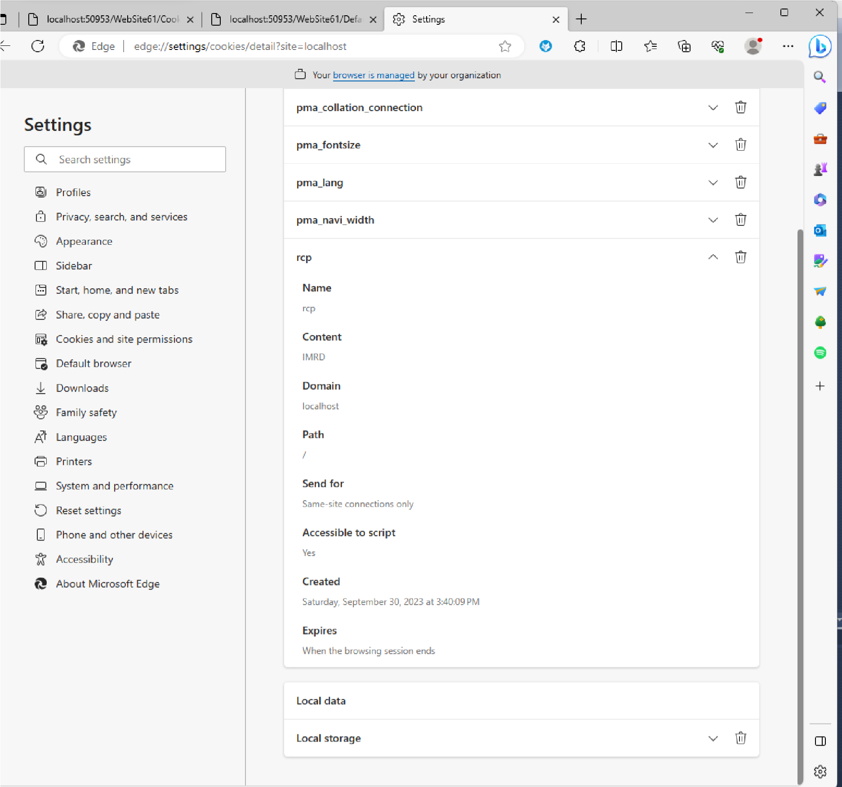

1. Write an ASP .net program to demonstrate different database operation (select,insert,update and delete) with Microsoft access database.

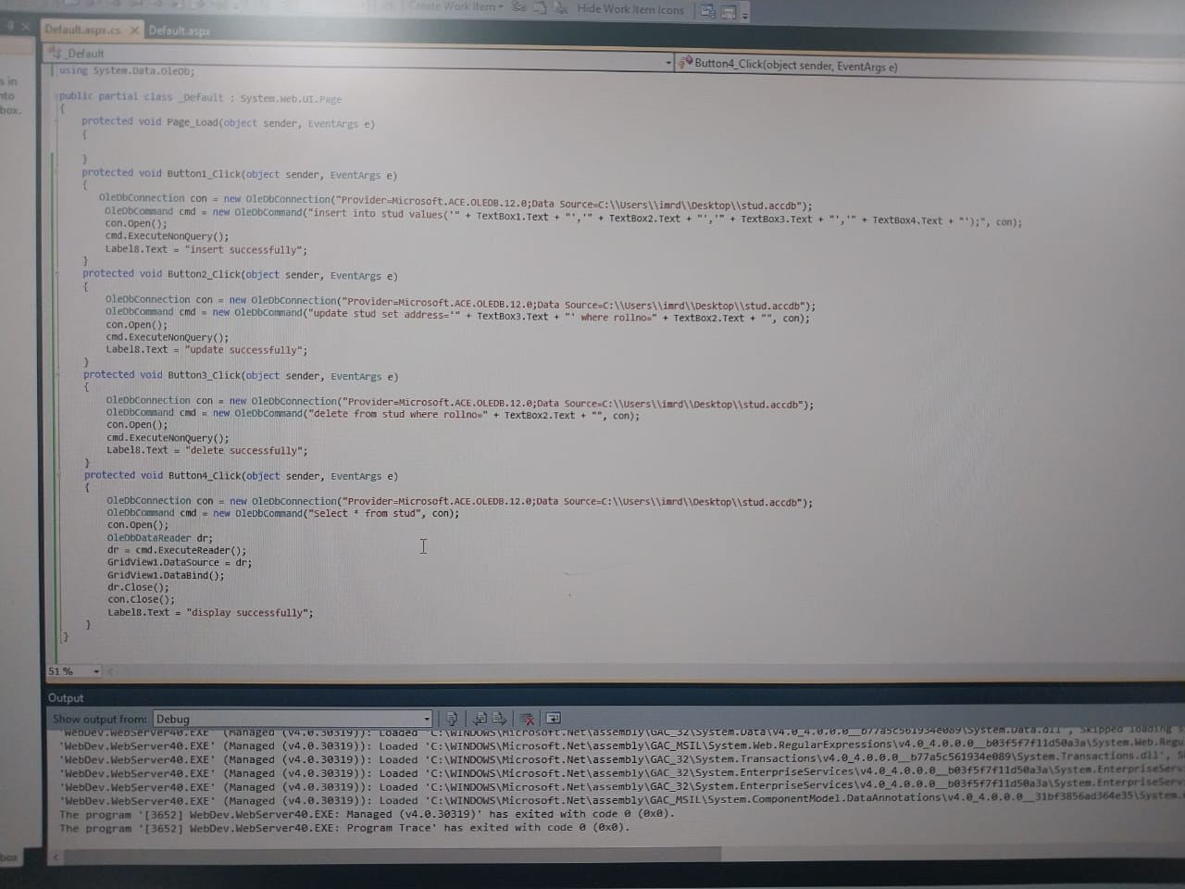

1. Write an ASP .net program using AdRotator Control.

Step 1 :- Open Visual Studio 2010.

Step 2 :- Create new Website.

Step 3:- Go to solution explorer > right click > Add new item > xml file.

Step 4:- Write a below code in xml file.

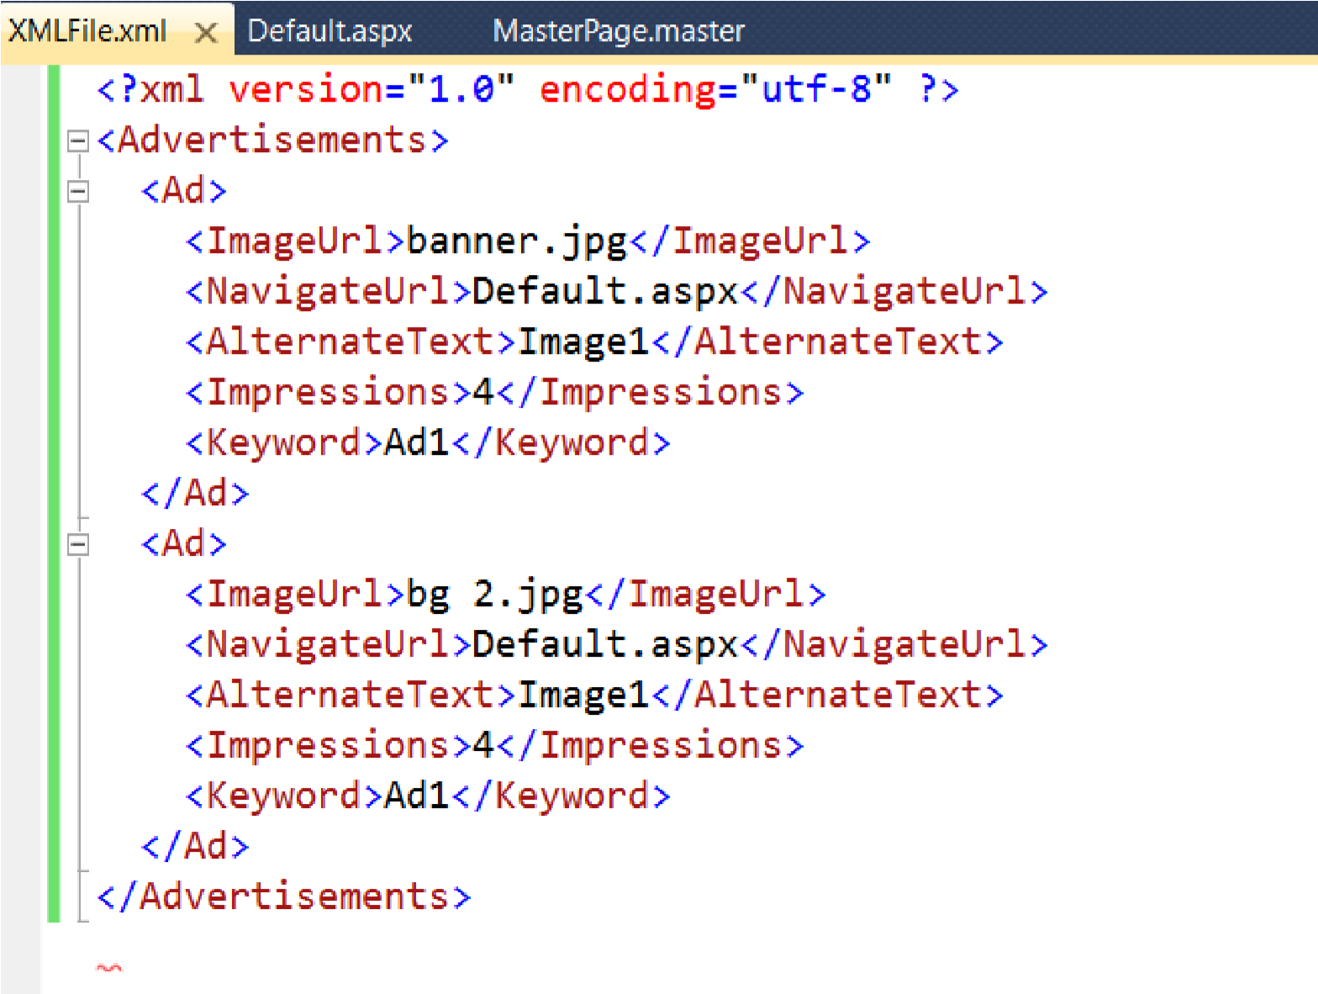

Step 5:- Go to Tool Box and place AdRotator Control on form.

Step 6:- Go to properties and select AdvertisementFile property and pass xml file Url.

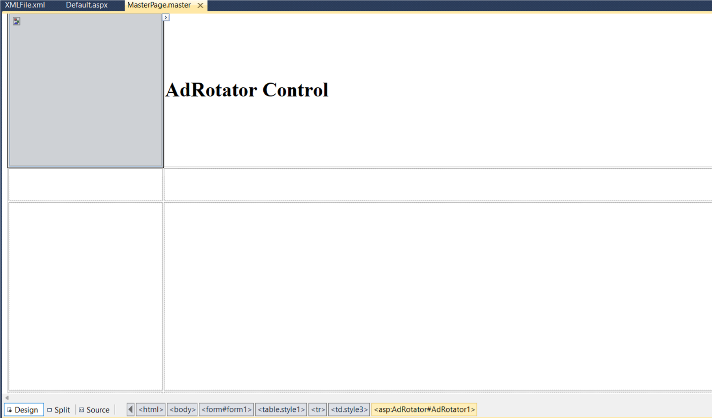

Step 7:- Run program.

